Table of Contents

1.0 Introduction 4

1.1 Project Background 4

1.2 Data Dictionary 5

1.2.1 Student Table 5

1.2.2 Lecturer Table 5

1.2.3 Subject Table 6

1.2.4 Result Table 6

2.0 Data Protection 7

2.1 Data Classification Matrix 7

2.2 Consideration for Enhancing Data Protection 8

2.2.1 Encryption 8

2.2.1.1 Transparent Data Encryption (TDE) 8

2.2.1.2 Column-Level Encryption (CLE) 8

2.2.2 Role-Based Access Control (RBAC) 8

2.2.3 Data Masking 9

2.2.4 Backup and Recovery 9

2.2.4.1 Full Backup 9

2.2.4.2 Differential Backup 10

2.2.4.3 Transaction Log (T-Log) Backup 10

2.2.4.4 Tracking Deleted Records 10

2.3 Implementation 12

2.3.1 Encryption 12

2.3.1.1 Transparent Data Encryption (TDE) 12

2.3.1.2 Column-Level Encryption (CLE) 14

2.3.2 Data Masking 16

2.3.2.1 Static Data Masking 16

2.3.2.2 Dynamic Data Masking 17

2.3.3 Backup and Recovery 18

2.3.3.1 Full Backup 19

2.3.3.2 Differential Backup 22

2.2.4.5 Transactional Log (T-Log) Backup 25

2.2.4.6 Backup Deleted Records and Recovery 28

3.0 Permission Management 30

3.1 Data Authorisation Matrix 30

3.1.1 Authorisation Matrix 30

3.1.2 Roles-User Mapping 34

3.2 Consideration in Permission Management 34

3.2.1 Role Level Access 34

3.2.1.1 Role-Based Access Control (RBAC) 34

3.2.2 Row Level Security 35

3.2.2.1 View 35

3.2.2.2 Stored Procedure 36

3.3 Implementation 36

3.3.1 Role-Based Access Control (RBAC) 36

3.3.1.1 Create Roles 36

3.3.1.2 Create Logins 37

3.3.1.3 Create Users 38

3.3.1.4 Assign Roles to Users 39

3.3.2 Views 39

3.3.2.1 Data Admin Role 39

3.3.2.2 Student Role 43

3.3.2.3 Lecturer Role 43

3.3.3 Stored Procedures 44

3.3.3.1 Student Role 44

3.3.3.2 Lecturer Role 46

3.3.4 Assign Permissions 48

3.3.4.1 Data Admin Role 48

3.3.4.2 Student Role 50

3.3.4.3 Lecturer Role 51

3.3.4 View Permissions for All Roles 52

3.3.5 Manage Permissions 54

3.3.5.1 Data Admin Role 54

3.3.5.2 Lecturer Role 55

3.3.5.3 Student Role 56

4.0 Auditing 58

4.1 Database Audit Matrix 58

4.2 Consideration for Auditing 59

4.2.1 Server Audit 59

4.2.2 System-Versioned Temporal Tables 59

4.2.3 SQL Triggers 60

4.3 Implementation 61

4.3.1 Server Audit 61

4.3.1.1 Audit Object 61

4.3.1.2 Server Audit Specification 62

4.3.1.3 Database Audit Specification 63

4.3.1.4 Login Server Audit 64

4.3.1.5 DDL Server Audit 65

4.3.1.6 DML Server Audit 66

4.3.1.7 DCL Server Audit 67

4.3.2 System-Versioned Temporal Tables 68

4.3.3 SQL Triggers 69

5.0 Summary 70

6.0 References 71

# Introduction

## Project Background

In the current digital environment, securing sensitive data is crucial for educational institutions that manage massive amounts of information. AP College, a well-known college in Kuala Lumpur, Malaysia, is adopting an Academic Information System (AIS) to enhance its operation and improve data management for students and staff. However, the initial database design lacks essential security features that expose it to various threats, such as unauthorised access, data breaches, and potential data loss.

This project seeks to improve the security of the AIS database by addressing the security concerns identified by the system architect. To secure the database from possible threats and maintain compliance with best practices in database security management, it is essential to develop and implement several robust security measures to protect the database against potential risks. These enhancements will ensure the integrity and confidentiality of data, including audits, data protection, backup process, encryption, and role-based access control (RBAC).

The main goal of this assignment is to suggest and implement security measures that mitigate the risks associated with unauthorised access, data manipulation, and accidental data loss. Furthermore, ensuring sensitive data remains protected through data classification, encryption and masking techniques and user roles and permissions are properly managed through RBAC to control access to data. The solution will be scripted using MS-SQL to allow for easy reproduction and demonstration of the proposed enhancement.

This documentation will outline the proposed security features for the AIS database, including data classification matrix, data protection techniques, permission management configuration, auditing setup, and backup and recovery strategies.

## Data Dictionary

### Student Table

|  |  |  |  |
| --- | --- | --- | --- |
| **Column Name** | **Data Type** | **Description** | **Constraints** |
| ID | VARCHAR(6) | Unique identifier for each student | Primary Key |
| SystemPwd | VARBINARY(max) | Encrypted password for student system access |  |
| Name | VARCHAR(100) | Full name of the student | Not Null |
| Phone | VARCHAR(20) | Contact phone number of the student |  |
| SensitiveInfo | NVARCHAR(255) | Sensitive Information (e.g., Address) |  |
| CreatedBy | NVARCHAR(50) | Identifier of the person who created the record |  |
| CreatedDate | DATETIME | Timestamp when the record was created | Default: GETDATE() |

Table : Data Dictionary – Student Table

### Lecturer Table

|  |  |  |  |
| --- | --- | --- | --- |
| **Column Name** | **Data Type** | **Description** | **Constraints** |
| ID | VARCHAR(6) | Unique identifier for each lecturer | Primary Key |
| SystemPwd | VARBINARY(max) | Encrypted password for lecturer system access |  |
| Name | VARCHAR(100) | Full name of the lecturer | Not Null |
| Phone | VARCHAR(20) | Contact phone number of the lecturer |  |
| Department | VARCHAR(30) | Department to which the lecturer is assigned |  |
| SensitiveInfo | NVARCHAR(255) | Sensitive Information (e.g., Address) |  |
| CreatedBy | NVARCHAR(50) | Identifier of the person who created the record |  |
| CreatedDate | DATETIME | Timestamp when the record was created | Default: GETDATE() |

Table : Data Dictionary - Lecturer Table

### Subject Table

|  |  |  |  |
| --- | --- | --- | --- |
| **Column Name** | **Data Type** | **Description** | **Constraints** |
| Code | VARCHAR(5) | Unique code for each subject | Primary Key |
| Title | VARCHAR(30) | Title of the subject |  |

Table : Data Dictionary - Subject Table

### Result Table

|  |  |  |  |
| --- | --- | --- | --- |
| **Column Name** | **Data Type** | **Description** | **Constraints** |
| ID | INT | Unique identifier for each result record | Primary Key, Identity (1, 1) |
| StudentID | VARCHAR(6) | Foreign key referencing Student (ID) | Foreign Key (Student(ID)) |
| LecturerID | VARCHAR(6) | Foreign key referencing Lecturer (ID) | Foreign Key (Lecturer(ID)) |
| SubjectCode | VARCHAR(5) | Foreign key referencing Subject (Code) | Foreign Key (Subject(Code)) |
| AssessmentDate | DATE | Date of the assessment |  |
| Grade | VARCHAR(2) | Grade awarded to the student for the subject |  |

Table : Data Dictionary - Result Table

# Data Protection

## Data Classification Matrix

|  |  |  |  |  |
| --- | --- | --- | --- | --- |
| **Level** | **Classification** | **Columns** | **Justification** | **Techniques** |
| 0 | Private | **Student:** SystemPwd  **Lecturer:** SystemPwd | Passwords are highly sensitive, only accessibly by individual for system authentication. | * Encryption * RBAC |
| 1 | Restricted | **Result:** Grade | Grades are sensitive and should be updated by only lecturers, students can only view their own | * RBAC * View-only access for students |
| 2 | Confidential | **Student:** SensitiveInfo  **Lecturer:** SensitiveInfo | Personal information, restricted to individual users, student or lecturer | * RBAC * Data masking |
| 3 | Internal | **Student:** Phone, CreatedBy, CreatedDate  **Lecturer:** Phone, CreatedBy, CreatedDate  **Result:** ID, AssessmentDate  **Subject:** Code, Title | Operational data necessary internal use, not highly sensitive but necessary for system function. | * RBAC * Data integrity checks |

Table : Data Classification Matrix

## Consideration for Enhancing Data Protection

### Encryption

#### 2.2.1.1 Transparent Data Encryption (TDE)

Transparent Data Encryption (TDE) is a security feature that encrypts the entire dataset while it is at rest, including transaction logs and backups, without having changes to the application or user interaction. It operates transparently, meaning that the encryption and decryption are automatic without affecting system performance or requiring modifications to the application (Microsoft Learn, 2024). It ensures that sensitive data such as personal details of students and lecturers and student grades in the AIS is encrypted on disk and cannot be assessed by unauthorised individuals, regardless of whether physical storage or backup is compromised. The consideration for using TDE in the AIS is its ability to protect all sensitive academic data from unauthorised access while maintaining the system's security and privacy. The transparent operation makes it practical to protect important academic information while keeping the system’s usability and user experience.

#### 2.2.1.2 Column-Level Encryption (CLE)

Column-Level Encryption (CLE) is a security measure that encrypts specific columns in a database, allowing for more granular control over sensitive data. CLE ensure that even if there is unauthorised access to the database, the encryption columns remain inaccessible without appropriate decryption keys (Shiftan, 2023). In the AIS, CLE can encrypt highly sensitive information such as passwords and other personal details at the column level, ensuring that these specific fields are protected while leaving the rest of the database unencrypted. The consideration for using CLE in the AIS is its ability to provide targeted encryption for the most sensitive data without introducing unnecessary overhearing for less important data. This approach to encryption allows for stronger security on critical fields while maintaining optimal database performance. CLE also support an access control approach, ensuring that only authorised users with proper permissions can view or modify encrypted data.(Zhang, 2023)

### Role-Based Access Control (RBAC)

Data masking is one of the data protection techniques used to hide sensitive information in a database by replacing it with fictitious, non-sensitive data. Data masking ensures that sensitive information n is hidden from unauthorised users, protecting important data such as passwords and sensitive information in the system (Zendata, 2024). In AIS, data masking can be implemented for sensitive files to protect information and ensure that it is not exposed to users without the proper permissions. The consideration for using data masking in the AIS is it can protect sensitive information while still allowing the system to function effectively. By masking sensitive information, the AIS ensures that unauthorised users cannot access or view the real information, reducing the risk of data breaches. Furthermore, sensitive information is further protected by the seamless integration of data masking with an access control approach, ensuring that only authorised individuals can view or update the unmasked data.

### Data Masking

Data masking is one of the data protection techniques used to hide sensitive information in a database by replacing it with fictitious, non-sensitive data. Data masking ensures that sensitive information n is hidden from unauthorised users, protecting important data such as passwords and sensitive information in the system (Zendata, 2024). In AIS, data masking can be implemented for sensitive files to protect information and ensure that it is not exposed to users without the proper permissions. The consideration for using data masking in the AIS is it can protect sensitive information while still allowing the system to function effectively. By masking sensitive information, the AIS ensures that unauthorised users cannot access or view the real information, reducing the risk of data breaches. Furthermore, sensitive information is further protected by the seamless integration of data masking with an access control approach, ensuring that only authorised individuals can view or update the unmasked data.

### Backup and Recovery

Backup and recovery are significant components of a strong data protection approach that ensures the availability and integrity of data during accidental data loss, system failure, or cyberattacks. A backup refers to creating copies of data regularly that can be saved safely from a separate location from the main database. Recovery involves restoring the data from these backups when necessary, such as during hardware failure, corruption or security incidents (Technotc, 2024). In AIS, this approach ensures that important information is backed up securely and can be recovered when needed, maintaining the system’s operational continuity.

#### Full Backup

A full backup creates a complete copy of the entire database, including all the data and structure. This type of backup is crucial for any backup strategy as it provides an entire overview of the system at a specific time (Fellows & Crocetti, 2024). In the AIS, full backups are essential for making sure that the system can recover information when needed. Full backups are usually performed less frequently since it is time-consuming and require more storage space. Hence, it should be combined with other types of backups to optimise performance and storage (Microsoft Learn, 2023).

#### Differential Backup

Differential backup captures only the data that has changed since the last full backup, making it more efficient and faster than performing repeated full backups (Fellows & Crocetti, 2024). In the AIS, differential backups allow for regular data protection without the overhead of a full backup, allowing quicker backups during operational hours. By using differential backups, AIS can maintain up-to-date backups of important academic information with minimal impact on the system’s performance, making it recover from potential data corruption or failure quickly while maintaining storage resources (Microsoft Learn, 2023).

#### Transaction Log (T-Log) Backup

Transaction log (T-log) backup captures all changes made to the database as the last T-log or full backup (Microsoft Learn, 2024). In the AIS, T-Log backups may be scheduled at frequent intervals to ensure that the system can recover data to a specific point in time before any failure or error. This frequent capture of changes is critical for maintaining data integrity, as it allows the system to react to the last committed transaction before an issue occurs. By using T-Log backups, AIS ensures minimal data loss and real-time recovery, which is essential in an academic environment where data is constantly being updated.

#### Tracking Deleted Records

Aside from traditional backup methods, the AIS includes a mechanism for tracking deleted records. This approach allows the system to keep a record of any deleted data, which can be restored without the need to perform a full database recovery. For example, if student data or academic records are accidentally deleted, data admins can recover specific records directly from the table that records deleted data, which can reduce the overhead and downtime associated with full restores. This functionality strengthens the system’s robustness by ensuring that accidental detentions do not result in permanent data loss. This feature to recover individual records efficiently enhances the overall reliability of the backup and recovery strategy, ensuring that AIS can maintain operational continuity even when facing accidental or intentional deletions.

The automated backup schedule will be managed using SQL Server Agent, to balance performance and storage efficiency while meeting the AIS’s Recovery Point Objective (RPO) of a maximum of 6 hours. Full backups are scheduled weekly through SQL Server Agent to establish a complete baseline, while daily differential backups provide regular protection without heavily impacting system performance. Additionally, T-Log backups, automated to run every 30 minutes, minimize potential data loss and ensure the system can recover quickly from any failure. This use of SQL Server Agent ensures that backups are consistently performed according to the schedule without manual intervention.

This layered backup approach ensures the AIS can recover quickly from any incident, maintaining data integrity and system continuity. Full, differential, and T-Log backups, combined with deleted data tracking, provide a comprehensive, efficient strategy for data protection and recovery.

## Implementation

### Encryption

#### 2.3.1.1 Transparent Data Encryption (TDE)

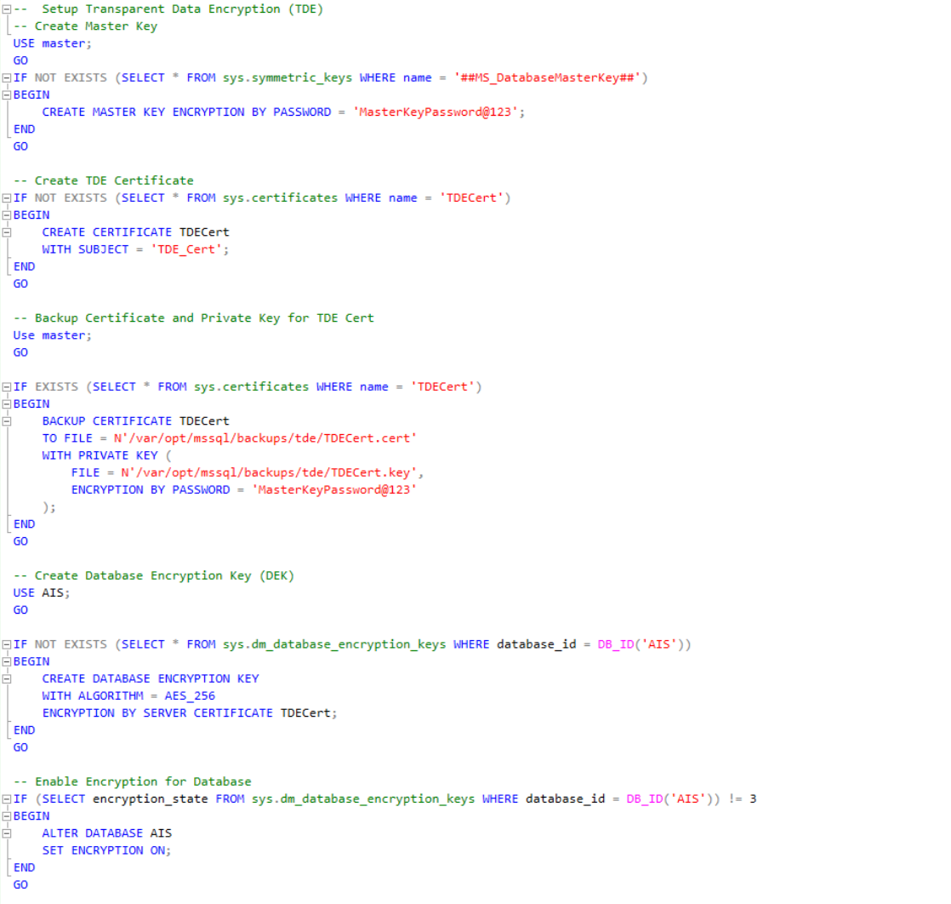

Figure : Code Snippet of TDE

The code snippet shows the setup process for Transparent Data Encryption (TDE) for the Academic Information System (AIS) database, ensuring the encryption of the database while it is at rest. It first checks if a Master Key exist in the master database, if it does not exist, it will then create one using a password for encryption. Next, the script creates a TDE certificate if it does not exist. The TDE certificate is then used to encrypt the Database Encryption Key (DEK). Then, the scrip switches to the AIS database and generates a DEK if it does not exist using the AES-256 encryption algorithm, secured by the TDE certificate. Finally, it checks the encryption state of the AIS; it enables encryption for the entire database if it is not yet enabled. This process is to make sure that the AIS database is encrypted and protected against unauthorised access on disk and in backup.

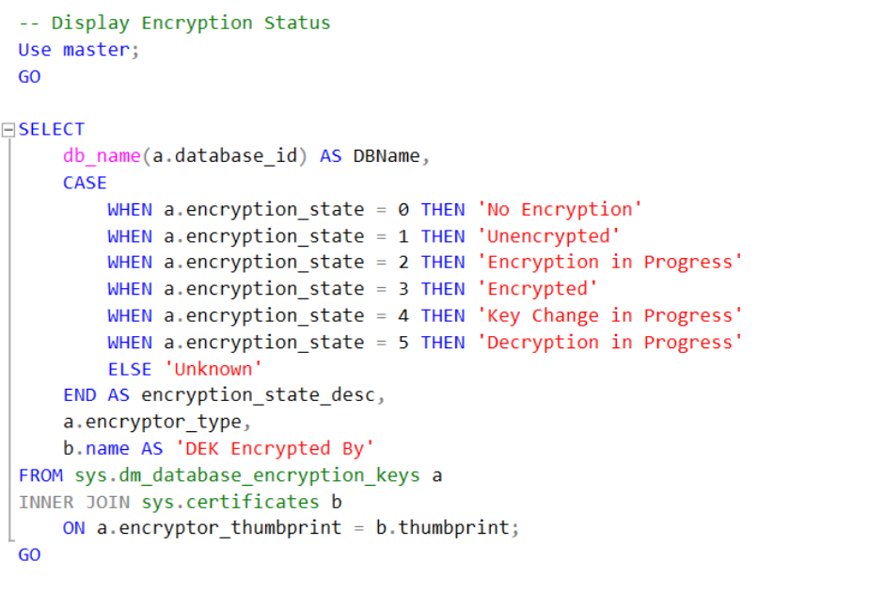

Figure : Code Snippet of Checking TDE Encryption Status

The code snippet checks the encryption status of databases on the server which focuses on TDE. It retrieves the database name, the current encryption state and the certificate used to encrypt the DEK.



Figure : Output of TDE Encryption Status

In the output, it shows that the AIS database is fully encrypted, and the DEK is being secured by *TDECert* certificates. This is used to monitor and very the encryption status of databases to ensure data security and compliance.

#### 2.3.1.2 Column-Level Encryption (CLE)

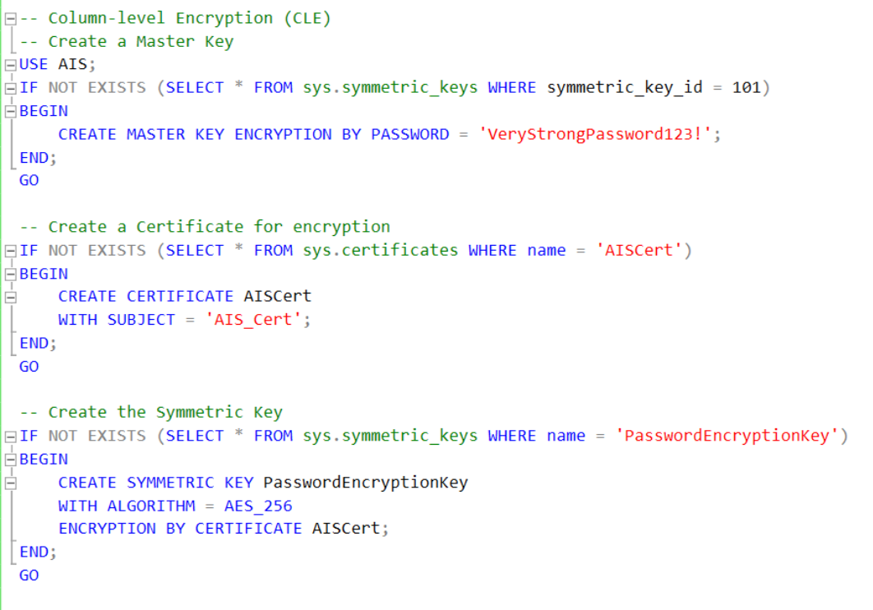

Figure : Code snippet of CLE

The code snippet shows the setup process for Column-Level Encryption (CLE) for the database by creating the necessary keys and certificates. First, it creates a master key if it does not already exist, which is used to protect other encryption keys in the system. Next, it generates a certificate named *AISCert*, which will be used to secure the symmetric key. Finally, a symmetric key named *PasswordEncryptionKey* is created using the AES-256 encryption algorithm, and it is encrypted by the *AISCert* certificate. This symmetric key will be used to encrypt specific sensitive data in the database, such as passwords, ensuring data protection at the column level.

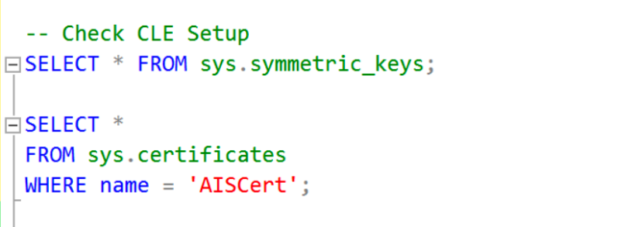

Figure : Code snippet of Checking CLE Setup

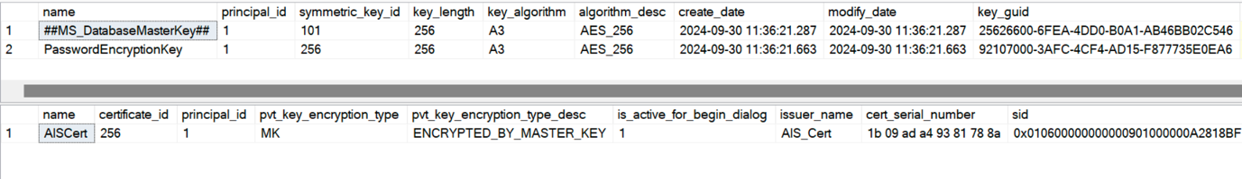

Figure : Output of Checking CLE Setup

The code snippet checks if the CLE is correctly set up in the system. First, it verifies the existence of the *PasswordEncryptionKey*, a symmetric key used to encrypt sensitive columns in the database using the AES-256 encryption algorithm. Then, it confirms that the *AISCert* certificate is in place, which secures the symmetric key, and its private key is encrypted by the Master Key. The symmetric key and certificate are used to ensure that sensitive data is encrypted and that the encryption keys are well-protected, improving the overall data security of the system.

### Data Masking

#### Static Data Masking

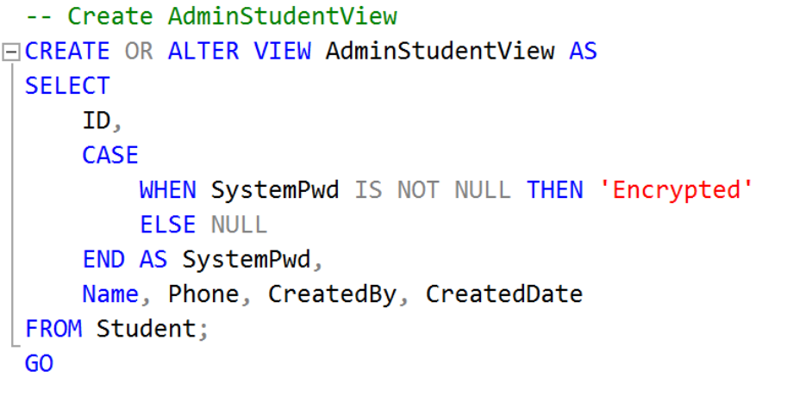

Figure : Code snippet of static data masking on the encrypted password

The code snippet demonstrates data masking in the *AdminStudentView*, used to mask the encrypted sensitive information in the *SystemPwd* column. When a password exists, it is replaced with the text *‘Encrypted,’* preventing the actual encrypted password from being displayed. This approach ensures that even encrypted values are not exposed to unauthorized users, maintaining a higher level of security and privacy for sensitive information. The view filters the sensitive data, ensuring that unauthorized users cannot see the actual encrypted data, and protecting the system from accidental exposure of sensitive details.

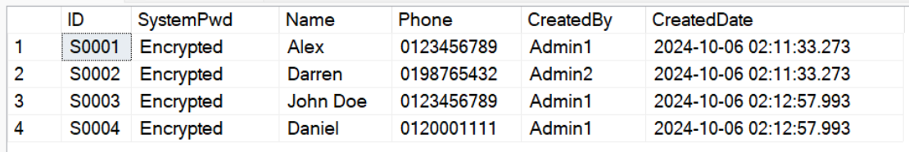

Figure : Output of static data masking

The output shows the static data masking applied to the SystemPwd columns ensures that sensitive information remains secure and inaccessible to unauthorised users while the other columns remain visible.

#### Dynamic Data Masking

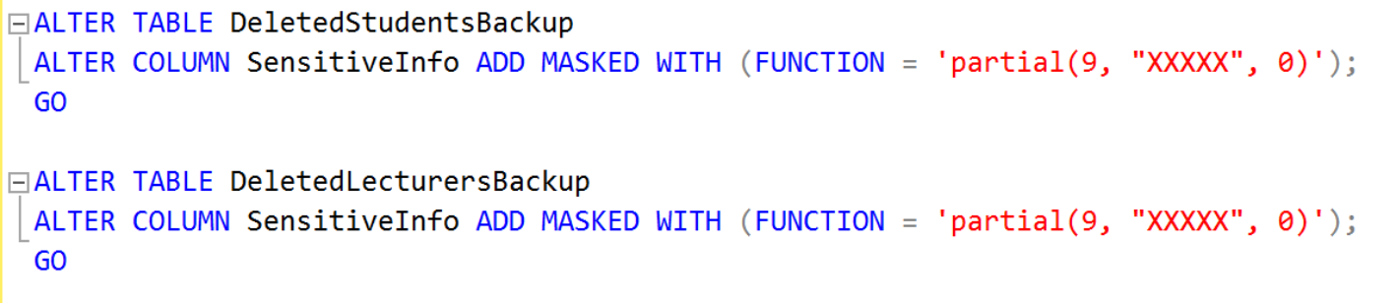

Figure : Code snippet of dynamic data masking

The code snippet demonstrates the application of dynamic masking to the *SensitiveInfo* column in the tables. By using the *ADD MASKED WITH* statement, a partial mask function is applied to hide sensitive data from unauthorised users. The mask shows the first nine characters of the sensitive information while replacing the remaining part with *“XXXXX”*. This ensures that sensitive details, such as addresses, are protected while still showing partial information. Users with permissions can access the dull, unmasked data. Dynamic data masking can improve data security by controlling the visibility field based on the user privileges.



Figure : Output of dynamic data masking

The output shows one example of the implementation of dynamic data masking in the *DeletedStudentBackup* table, where sensitive information is partially masked to protect privacy. For instance, the sensitive information of student *“S0006”* is masked, showing *“Address: XXXXX”* instead of the full address, while student *“S0005”* has no sensitive info displayed. Data masking ensures that sensitive devices are hidden from unauthorised users, enhancing data security by allowing only authorised roles, such as super admin, to view unmasked data. This approach provides an additional layer of security, preventing the exposure of confidential information while maintaining data integrity.

### Backup and Recovery

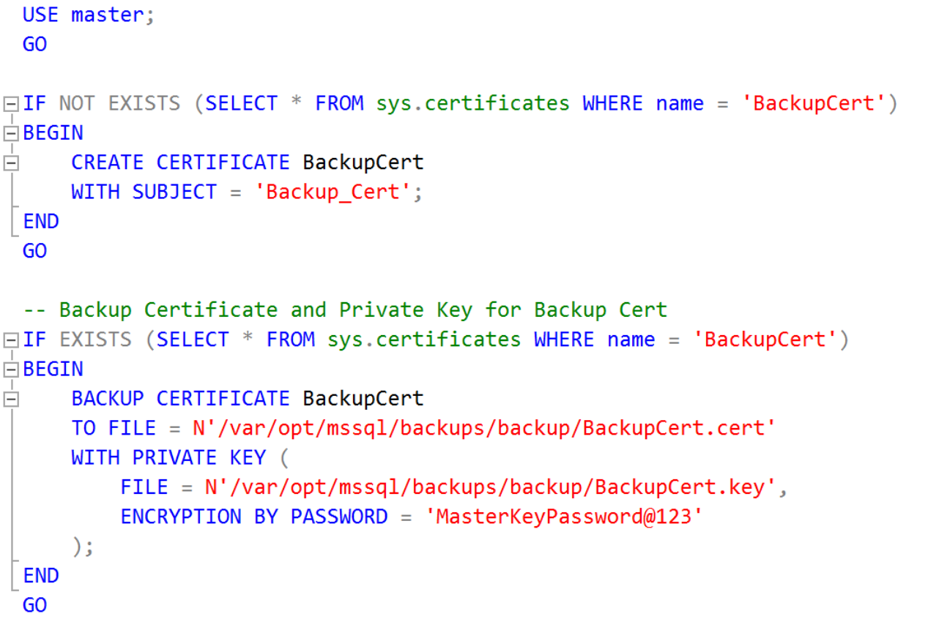

Figure 11: Code snippet of setup for backup

The code snippet sets and secures the certificate used for encrypting database backups. It first checks if the *BackupCert* certificate exists, and if not, it will create one within the master database. The certificate is used for encrypting backups to ensure data security. Once the certificate is created, the code will back up the cert and its private key. The certificate and private key are saved to a specific location. The private key is encrypted with a password for further protection. Baking up the certificate and private key is important as they are needed to decrypt and restore any encrypted database backups.

#### Full Backup

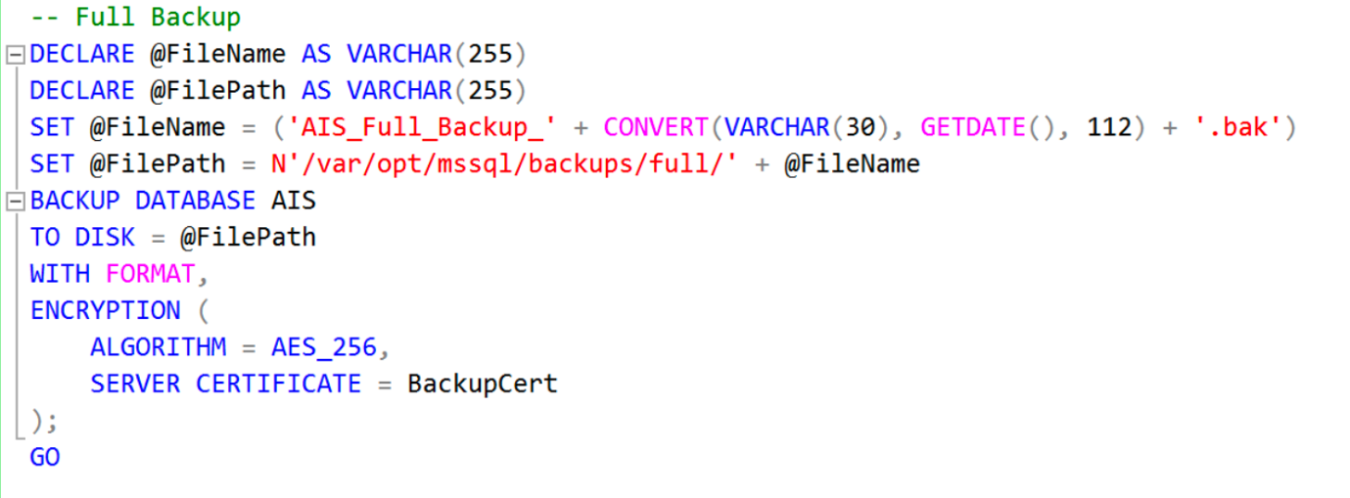

Figure 12: Code snippet of Full Backup

The code snippet shows the full backup of the AIS database, encrypting it with the AES-256 algorithm using the *BackupCert* certificate for security. The backup file is dynamically named with the current date and stored in the specified directory. The *WITH FORMAT* option ensures a new media set is created and overwrites any existing backups. This approach ensures that the database is securely backed up, with encryption protecting the data against unauthorised access.

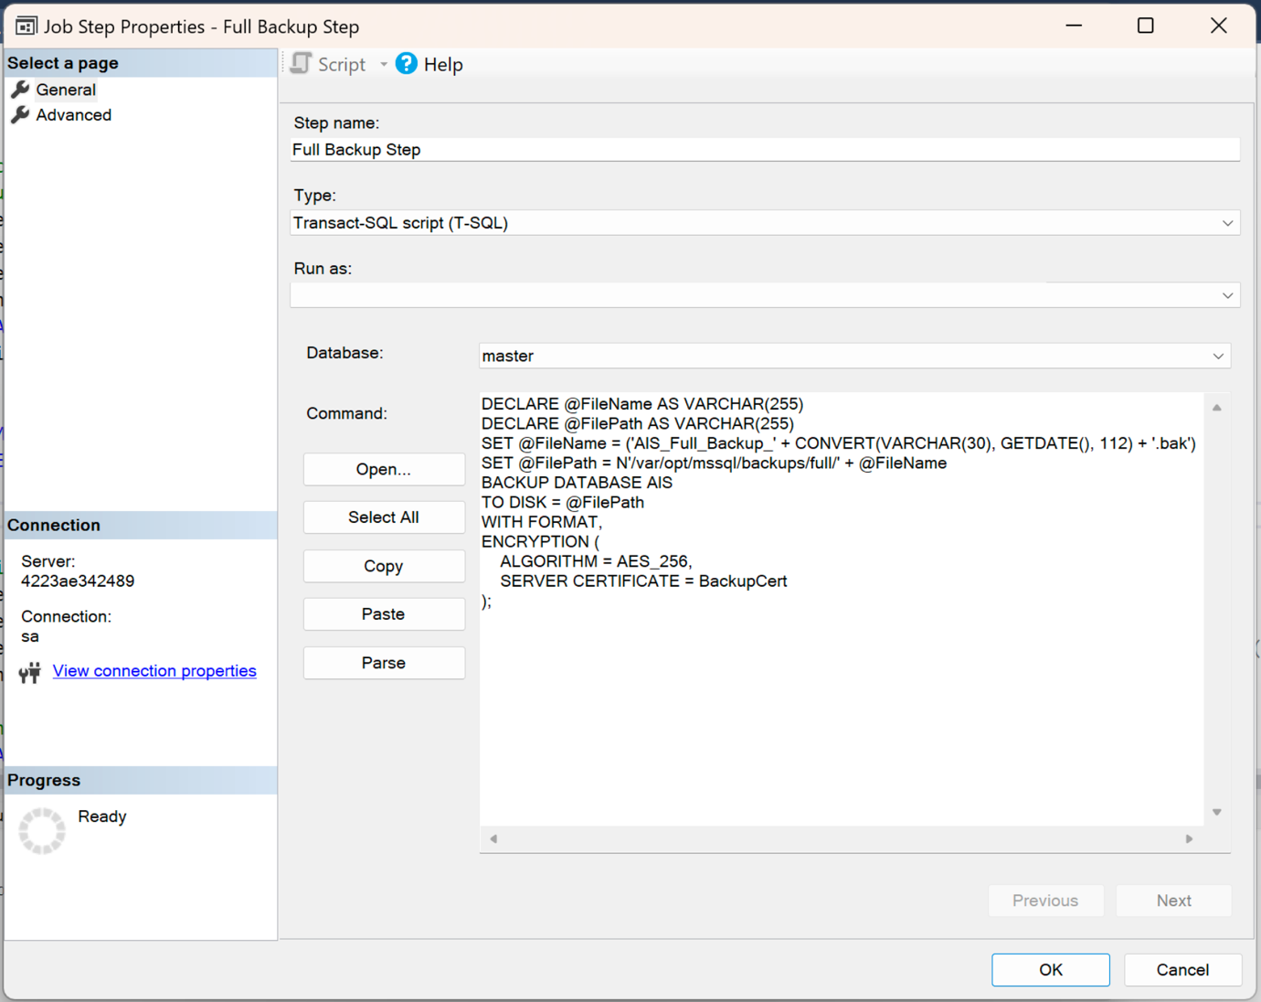

Figure 13: SQL Server Agent - Full Backup Step

This is the configuration of an automated full backup process for the AIS database using SQL Server Agent. By pasting the T-SQL code into the Command section of the Job Step Properties, the SQL Server Agent will execute the script at scheduled intervals. This means that the backup will happen automatically based on the specified schedule.

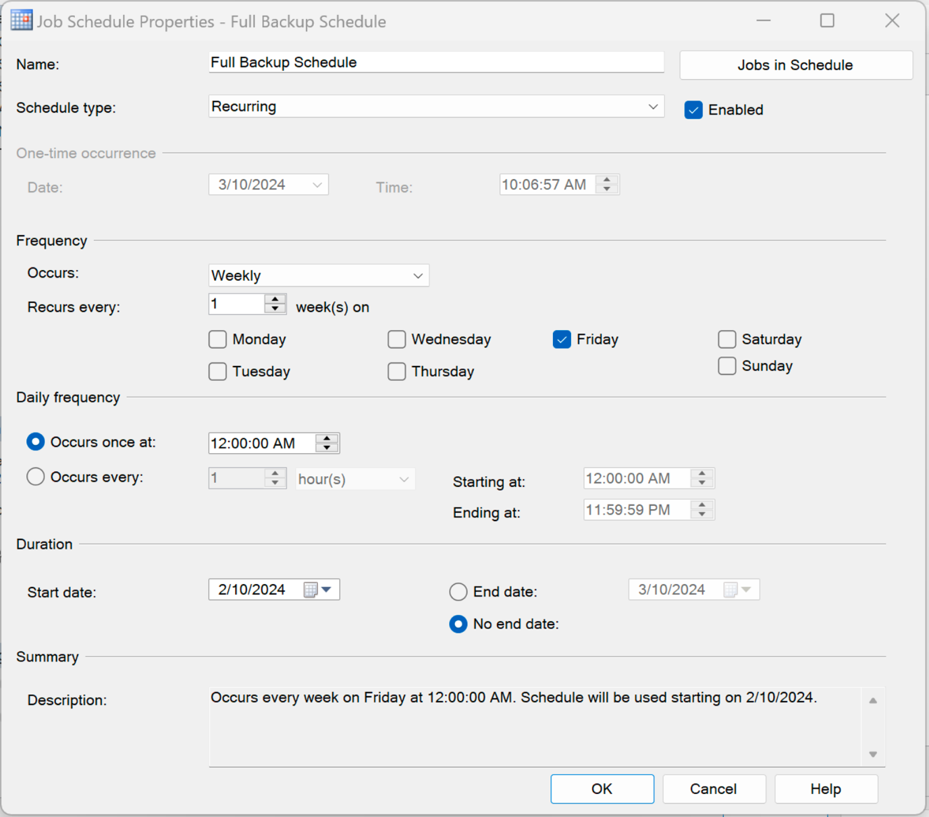

Figure 14: SQL Server Agent - Full Backup Schedule

The Job Schedule Properties in the SQL Server Agent defines the automated scheduling for the Full Backup of the AIS database. The schedule is set to run weekly, ensuring that the backup job will execute automatically at regular intervals. This ensures that a consistent backup routine is implemented, protecting the database without the need for manual input.

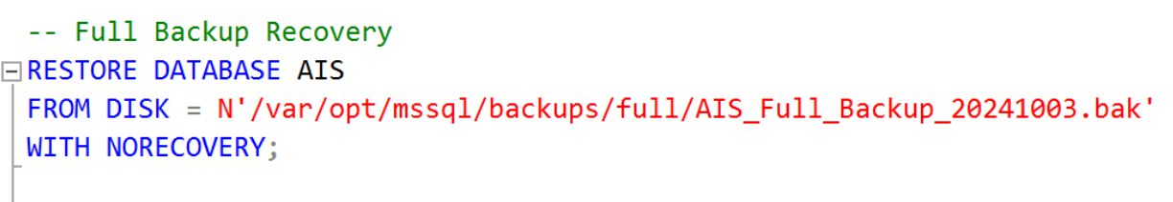

#### Differential Backup

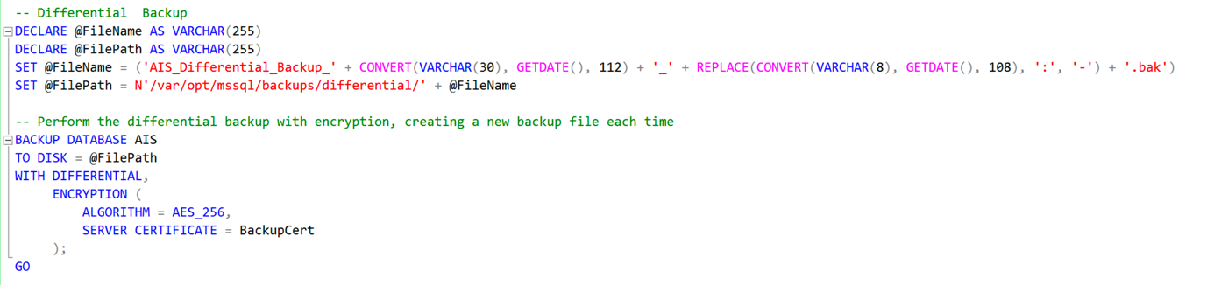

Figure 15: Code snippet of Differential Backup

The code snippet shows the differential backup of the AIS database, encrypting it with the AES-256 algorithm using the *BackupCert* certificate for security. The backup file is dynamically named with the current date and time and stored in the specified directory. This approach helps to minimise storage usage and backup time compared to full backups while maintaining data integrity and security.

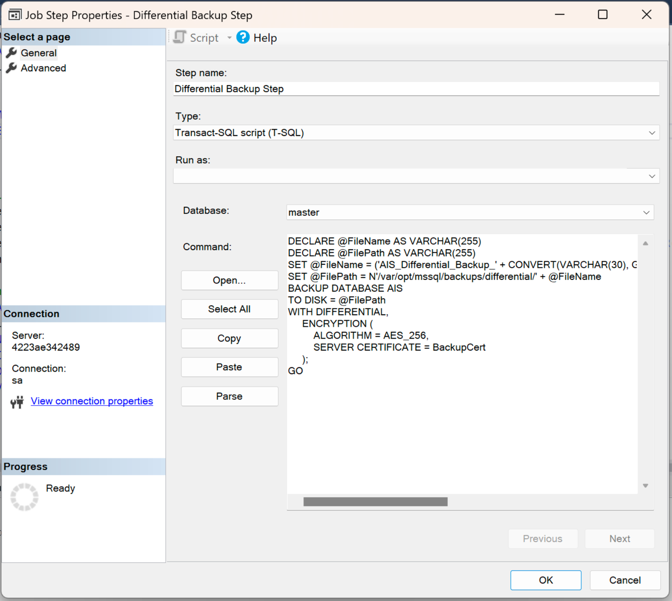

Figure 16: SQL Server Agent - Differential Backup Step

This is the configuration differential backup in the Job Step Properties for the AIS database using SQL Server Agent. By pasting the T-SQL code into the Command section of the Job Step Properties, the SQL Server Agent will execute the script at scheduled intervals. This means that the differential backup will happen automatically based on the schedule defined in the SQL Server Agent. This configuration allows the SQL Server Agent to automate differential backups, ensuring they run reliably and consistently without manual intervention.

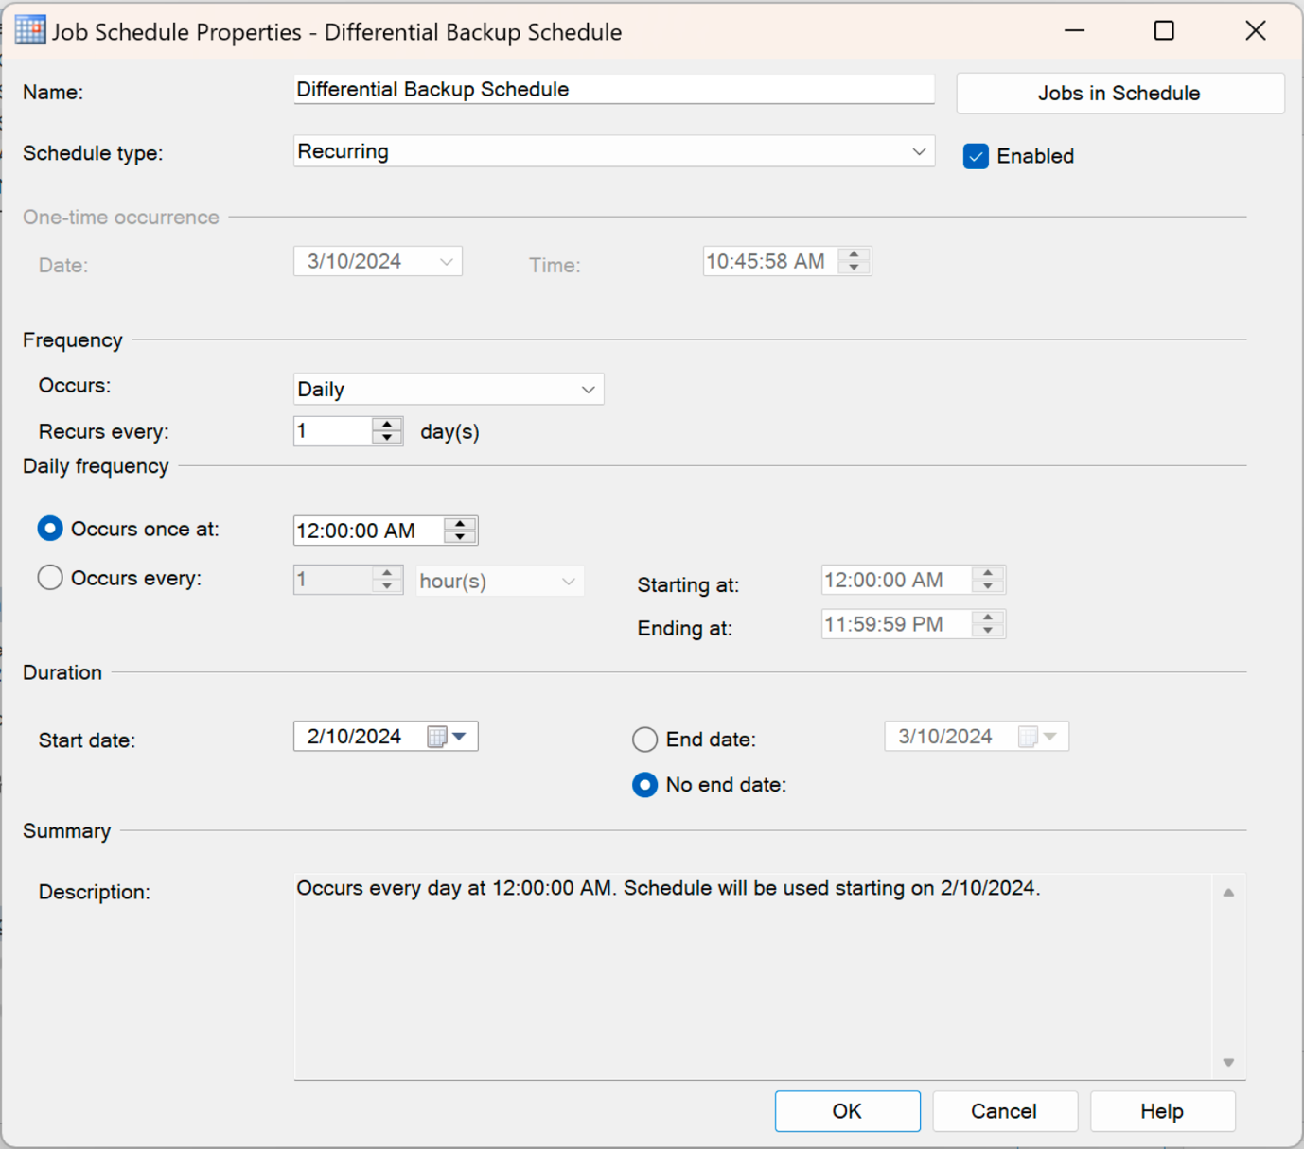

Figure : SQL Server Agent - Differential Backup Schedule

The Job Schedule Properties in the SQL Server Agent defines the automated scheduling for the Differential Backup of the AIS database. The schedule is set to run daily, ensuring that the backup job will execute automatically at regular intervals. This ensures that only the data changed since the last full backup is captured, maintaining a more frequent backup routine without needing to run a full backup every day. The automated schedule helps protect the database consistently while reducing the time and storage required for backups, all without the need for manual input.

#### Transactional Log (T-Log) Backup

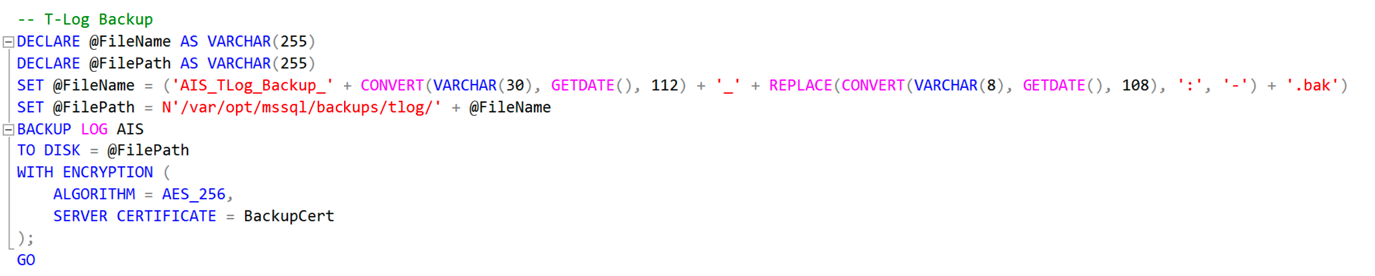

Figure : Code snippet of T-Log Backup

The code snippet shows the T-Log backup of the AIS database, encrypting it with the AES-256 algorithm using the *BackupCert* certificate for security. The backup file is dynamically named with the current date and time and stored in the specified directory. This approach ensures that all changes made to the database since the last full or differential backup are captured. T-Log backups help reduce the risk of data loss by allowing point-in-time recovery and ensuring the integrity of database operations.

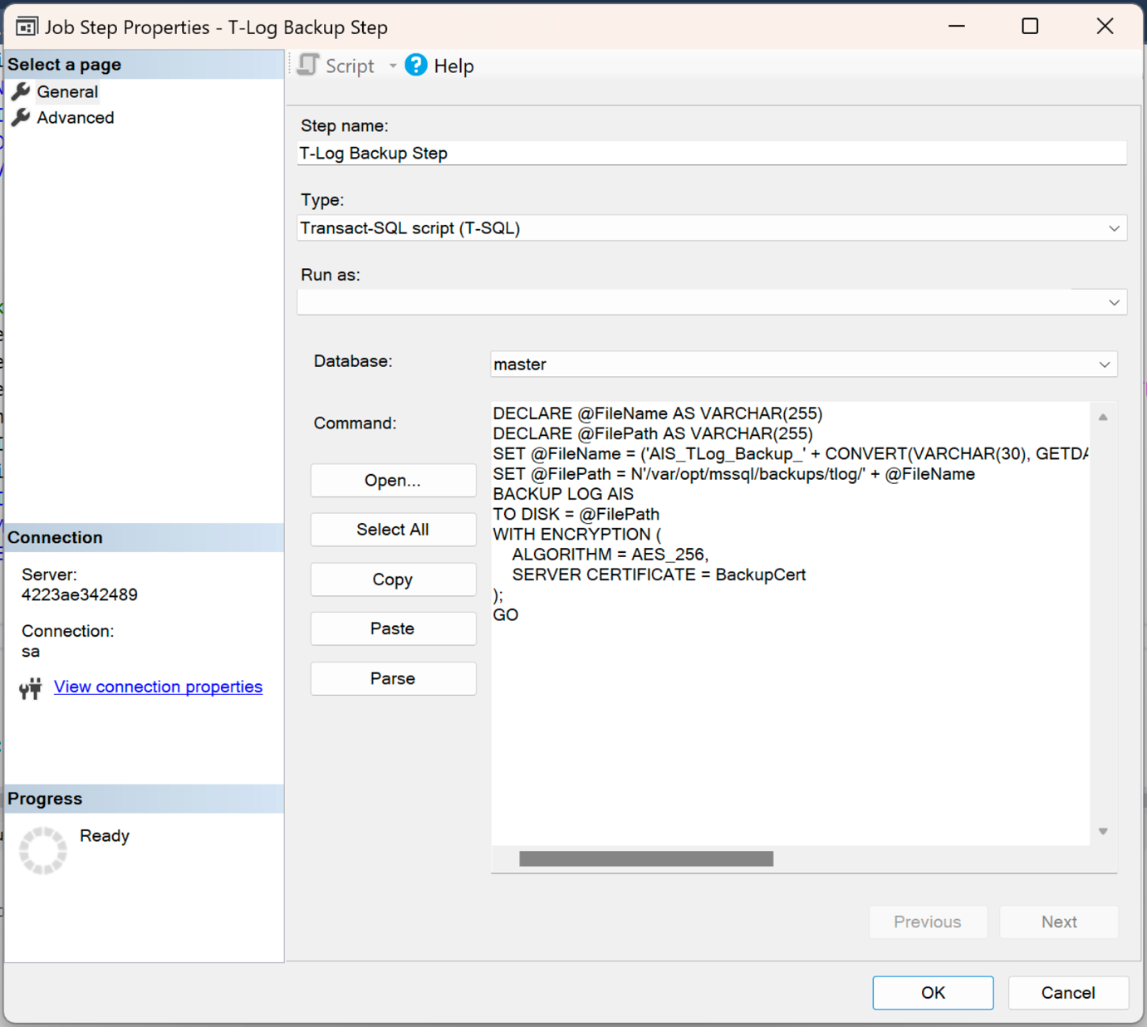

Figure : Server Agent – T-Log Backup Step

This is the configuration for a T-Log backup in the Job Step Properties for the AIS database using SQL Server Agent. By pasting the T-SQL code into the Command section of the Job Step Properties, the SQL Server Agent will execute the script at scheduled intervals. This means that the T-Log backup will happen automatically based on the schedule defined in the SQL Server Agent. This configuration allows the SQL Server Agent to automate transaction log backups, ensuring they run reliably and consistently without manual intervention, capturing all changes made to the database and ensuring data integrity.

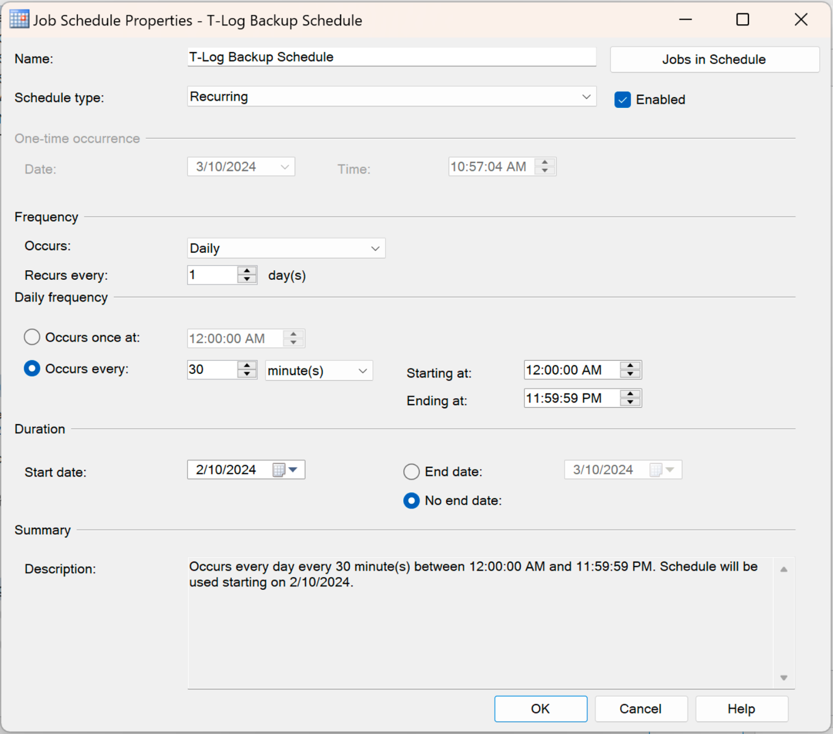

Figure : SQL Server Agent - T-Log Backup Schedule

The Job Schedule Properties in the SQL Server Agent defines the automated scheduling for the T-Log Backup of the AIS database. The schedule is set to run every 30 minutes, ensuring that the transaction log backup job will execute automatically at regular intervals throughout the day. This schedule captures all database changes since the last full or differential backup, allowing for point-in-time recovery and minimising data loss. The automated schedule ensures consistent protection of the database while reducing the need for manual intervention, enabling more frequent backups without significantly impacting system performance or storage requirements.

#### Backup Deleted Records and Recovery

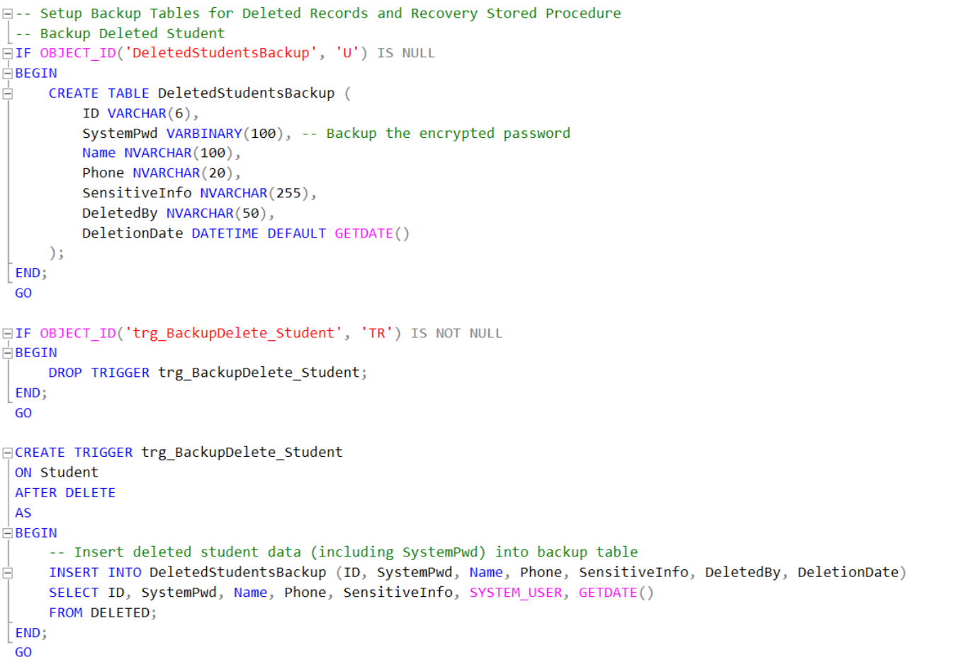

Figure : Code snippet of backing up deleted records.

The code snippet demonstrates one example of backup deleted records using a backup table and an *AFTER DELETE* trigger in SQL Server. A backup table is created to store details of the deleted student records, including all the information like encrypted passwords, names, phone numbers and other personal data. Besides, it logs who performed the deletion and the timestamp of the deletion. A trigger is then created, which automatically activates after any record is deleted. This trigger inserts the deleted data into the backup table, making sure that even when records are deleted from the table, they are not permanently lost. This provides an effective solution for tracking deleted records and allows recovery, making it a significant tool for maintaining data integrity and security.



Figure : Output of deleted records table

The output shows the table records the deleted records, including sensitive information and the encrypted password. It also logs who performed the deletion and when the deletion occurred.

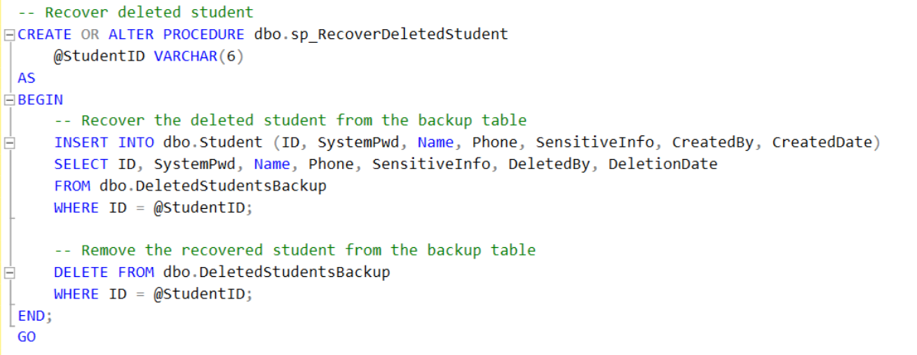

Figure : Code snippet of recovering deleted records

The code snippet shows a stored procedure to recover deleted records from the backup table. When a record is deleted, it is moved to the backup table, which allows the recovery of those records. In this case, the stored procedure student’s ID is input and performs the key action: restore the deleted records and remove the recovered data from the backup table. This process ensures that the deleted records can be easily recovered if needed while the backup table remains organised and contains only records that have not been restored. It is an effective approach to recover deleted data if there is accidental deletion.

# Permission Management

## Data Authorisation Matrix

### Authorisation Matrix

| **Rule #** | **Role** | **Permission Type** | **Object** | **Privilege** | **Note** |
| --- | --- | --- | --- | --- | --- |
| R1 | Data Admin | Grant | Database: AIS | Create User, Alter Any User, Control | Create and manage student/lecturer user but cannot modify or access sensitive data. |
| R2 | Data Admin | Grant | Views:  AdminUserView,  AdminStudentView,  AdminLecturerView,  DeletedStudentsBackupView,  DeletedLecturersBackupView | Select | Manage student and lecturer account but cannot access sensitive information. |
| R3 | Data Admin | Grant | Table: Student, Lecturer | Insert, Delete | Mange student and lecturer records but is denied access to sensitive column like *SystemPwd* and *SensitveInfo.* |
| R4 | Data Admin | Grant | Table: Subject | Select, Insert, Update, Delete | Manage subject information. |
| R5 | Data Admin | Grant | Stored Procedure:  sp_RecoverDeletedStudent, sp_RecoverDeletedLecturer, sp_RecoverDeletedSubject | Execute | Recover deleted records. |
| R6 | Data Admin | Deny | Table:  DeletedStudentsBackup,  DeletedLecturersBackup | Unmask | Cannot view unmask sensitive information in these tables. |
| R6 | Data Admin | Deny | Table:  Student (SystemPwd, SensitiveInfo),  Lecturer (SystemPwd, SensitiveInfo) | Select, Update | Denied access to sensitive information in the sensitive information in the Student and Lecturer tables. |
| R7 | Data Admin | Deny | Table:  DeletedStudentsBackup (SystemPwd, SensitiveInfo), DeletedLecturersBackup (SystemPwd, SensitiveInfo) | Select | Denied access to sensitive information: *SystemPwd* and *SensitveInfo.* |
| R8 | Data Admin | Deny | Table: Result | Select, Insert, Update, Delete | Cannot access of modify student grades. Protect student privacy and data integrity. |
| R9 | Data Admin | Deny | Schema: dbo | Alter | Cannot make any structural changes within the dbo schema. |
| R10 | Data Admin | Deny | Audit | Alter | Cannot modify or alter the database audit system. |
| R11 | Student | Grant | Symmetric Key: PasswordEncryptionKey | Control | To decrypt password. |
| R12 | Student | Grant | Certificate: AISCert | Control | To decrypt password. |
| R13 | Student | Grant | Stored Procedure:  sp_StudentSelfInfo, sp_StudentUpdateInfo | Execute | View and update their own data only. |
| R14 | Student | Grant | View: StudentResultView | Select | View their own result only. |
| R15 | Student | Grant | Table: Subject | Select | Access subject details. |
| R16 | Student | Deny | Table: Student, Result | Select, Insert, Update, Delete | Prevent modifying any data in the Student or Result tables |
| R17 | Student | Deny | Database: AIS | Alter | Cannot make any structural changes to the database. |
| R18 | Lecturer | Grant | Symmetric Key: PasswordEncryptionKey | Control | To decrypt password |
| R19 | Lecturer | Grant | Certificate: AISCert | Control | To decrypt password |
| R20 | Lecturer | Grant | Stored Procedure:  sp_LecturerSelfInfo, sp_LecturerUpdateInfo | Execute | Can view and update their own data only |
| R21 | Lecturer | Grant | Table: Result | Select, Insert, Update | Can view and update grades, ensuring only authorised staff can modify student result |
| R22 | Lecturer | Grant | Views:  LecturerStudentView, LecturerView | Select | Can view students and other lecturers’ information but cannot modify the data |
| R23 | Lecturer | Deny | Table: Student. Lecturer. Result | Delete | Cannot delete records in the student, lecturer, and result table. |
| R24 | Lecturer | Deny | Table:  Student (SystemPwd, StudentInfo),  Lecturer (SystemPwd, StudentInfo) | Select, Update | Denied access to sensitive information: *SystemPwd* and *SensitveInfo.* |
| R25 | Lecturer | Deny | Database: AIS | Alter | Cannot make any structural changes to the database. |

Table : Authorisation Matrix

### Roles-User Mapping

|  |  |
| --- | --- |
| **Roles** | **Users** |
| Data Admin | Admin1, Admin2 |
| Student | S0001, S0002 |
| Lecturer | L0001, L0002 |

Table : Roles-Users Mapping

## Consideration in Permission Management

### Role Level Access

#### 3.2.1.1 Role-Based Access Control (RBAC)

Role-Based Access Control (RBAC) is a security framework that assigns access rights based on a user’s role within an organisation. RBAC allows for managing user permission by grouping users into roles with assigned permission, ensuring that access to sensitive data is restricted according to their respon. Hilities (Zhang, 2023). In the AIS, RBAC are implemented to control access for different user groups, hence, these users are created, including **data admin, students, and lecturers.** For example, students can only view their academic results, while lecturers can input or update student grades. On the other hand, data admin may have broader access to manage the system without interacting with sensitive information. The consideration for using RBAC in the AIS is its ability to enhance access management by reducing the complexity of assigning individual permissions to users. The permissions are defined at the role level, and users are assigned roles based on their duties. This approach ensures that sensitive data remains secure and simplifies the management of permissions. Besides, RBAC integrates well with access control policies, ensuring that only authorised individuals with specific roles can view or update certain data, this improves the protection level of sensitive information.

**Main RBAC Framework for Each Role:**

|  |  |
| --- | --- |
| **Role** | **Framework** |
| DataAdminRole | Manages user accounts, performs CRUD operations on student and lecturer data, but is restricted from accessing sensitive information like passwords and cannot alter results. |
| LecturerRole | Can view and update their own details, insert and update student grades, and view limited student information (name, phone), but cannot delete records or access sensitive data. |
| StudentRole | Can view their own academic results and update their personal details, but cannot view or modify other students' data, lecturer data, or sensitive information. |

Table : RBAC Framework

### Row Level Security

Row-Level Security (RLS) is a more fine-grained security mechanism that controls access to specific rows in a table based on the user’s identity or role. RLS ensures that users can only view or modify the rows they are authorized or allowed to access. Which is useful for AIS database as it has multiple roles and each users can only see or access data relevant to them.

The key components of RLS is applying security predicates, which are rules that control which rows which user can access. Mainly there are two types, filter predicates and block predicates. Filter predicates determine which rows user can see or view, while block predicates prevent user rom modifying specific rows. The current user's login or role is used to filter the rows they can see or modify. For example, a student can only view their own grades, while a lecturer can view grades for their students.

In this security model, both Role-Level Access and Row-Level Security are used together to provide comprehensive access control and more robust security. Combining both mechanisms will make sure that users have the right permissions to access the appropriate tables, while also limiting them to specific rows within those tables based on their identity or role. This layered approach has strengthened overall database security of AIS.

#### 3.2.2.1 View

A view is a virtual table based on a SELECT query that retrieves specific data from one or more tables in AIS database. Views does not store data in themselves, but it acts as a filtered or formatted version of the data in existing tables. Views allow the researchers to limit the rows or columns that a user can see. By creating a view with a WHERE clause or filtering condition, you can ensure that users only have access to the relevant data.

In the context of Row-Level Security, views can be used to filter rows based on the user’s identity or role. For example, in AIS database, a student should only see their own results, and this can be achieved by creating a view that applies a filter for the logged-in student.

#### 3.2.2.2 Stored Procedure

A stored procedure is a saved collection of SQL statements or query that can be executed in one go as a single unit. Stored procedures can encapsulate multiple logics, allow input parameters, and control what actions a user can perform. Procedures allow bundling of multiple SQL statements together, such as SELECT, INSERT, UPDATE, and DELETE operations into a reusable process. Next, stored procedures can accept user input parameters, making it more flexible to use in SQL. Moreover, stored procedures can also control how data is accessed or modified by enforcing certain rules or conditions, such as checking the correct user based on username or other parameters. Stored procedures are particularly useful for enforcing RLS when users need to perform actions on data but only on data they are authorized to access.

## Implementation

### Role-Based Access Control (RBAC)

#### Create Roles

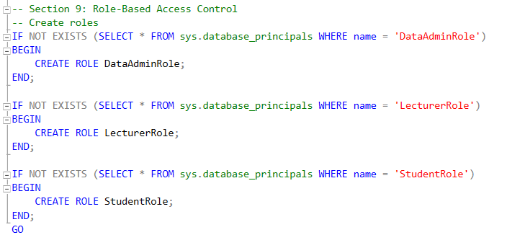

Figure : Code snippet of creating roles

Firstly, to set up Role-Based Access Control with Role Level Access and Row Level Security was applied. The researchers must first do the creation of roles, and user logins, and the assignment of permissions to these roles. The above code is to create three distinct roles, *DataAdminRole, LecturerRole*, and *StudentRole*. Each role represents a different level of access and functionality within the AIS database and later will be used to assign permissions and manage user access.

#### Create Logins

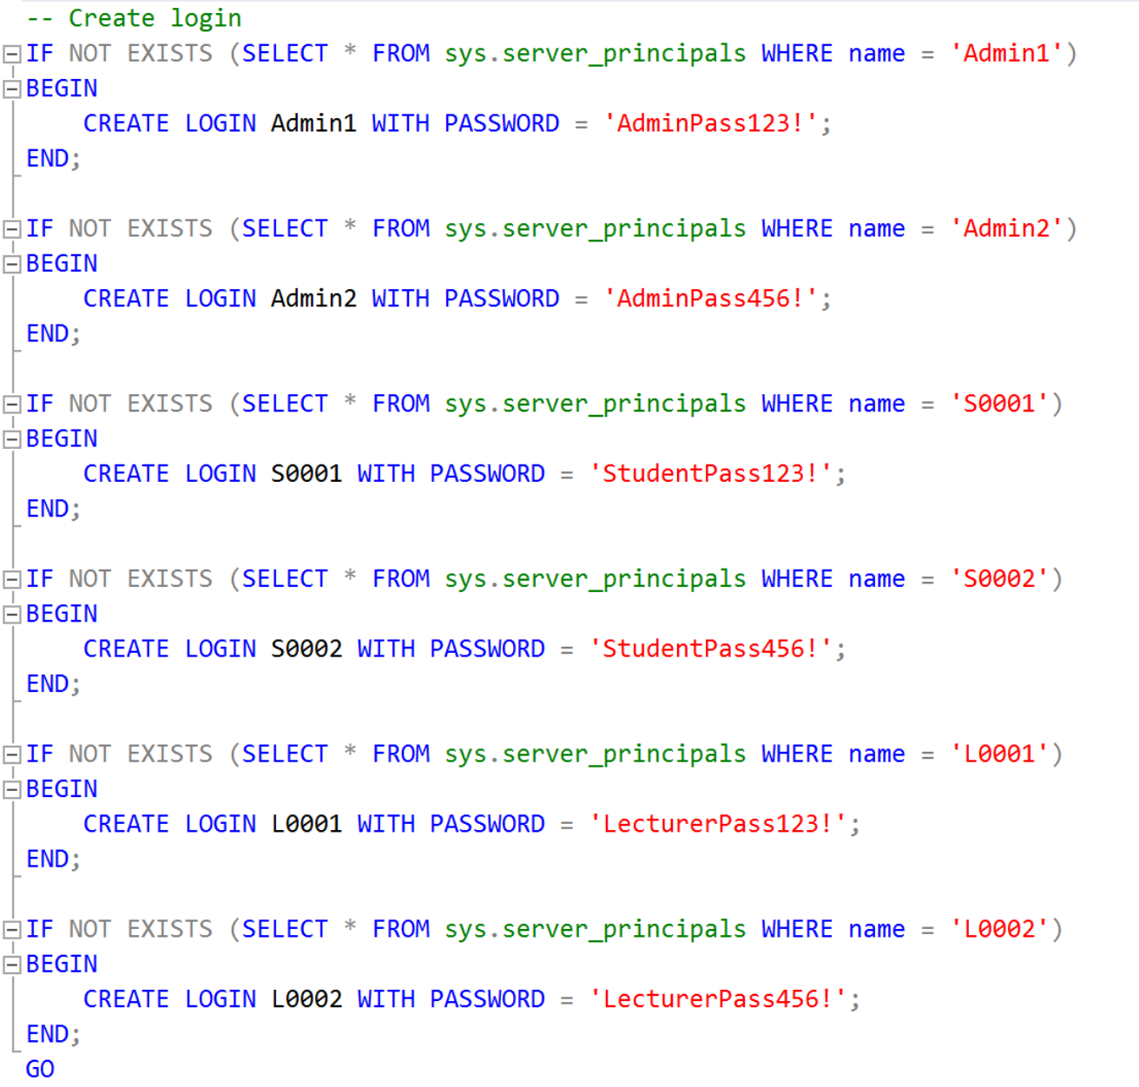

Figure : Code snippet of creating logins

The next code is to create server-level logins for users such as Data Admins, Lecturers, and Students within AIS database, by using *‘IF NOT EXISTS’* condition, the code ensures that logins are only created if they don't already exist to prevent duplication. Each login is also associated with a unique username and password only, and these logins will later be mapped to the roles created earlier, to allow permission management later to be more efficient and secure. This approach enhances security by enforcing the principle of least privilege, ensuring that each user only has access to data and functions necessary for their role, with further security measures like password policies and regular monitoring recommended for best practices.

#### Create Users

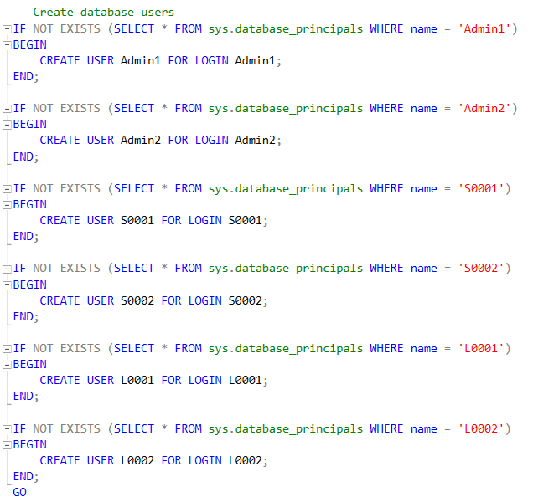

Figure : Code snippet of creating users

Next, this code creates database users by linking the previous created server-level logins to corresponding database-specific users. Similarly, the *‘IF NOT EXISTS’* condition has used here again to ensure that a user with the specified name does not already exist in the database *‘sys.database_principal’*. If the user does not exist, the *‘CREATE USER’* statement will then create a database user and link it with the corresponding login like linking *‘Admin1’* to *‘S0001’*. This process ensures that each login has a corresponding user within the database, allowing them to be assigned specific permissions and roles.

#### Assign Roles to Users

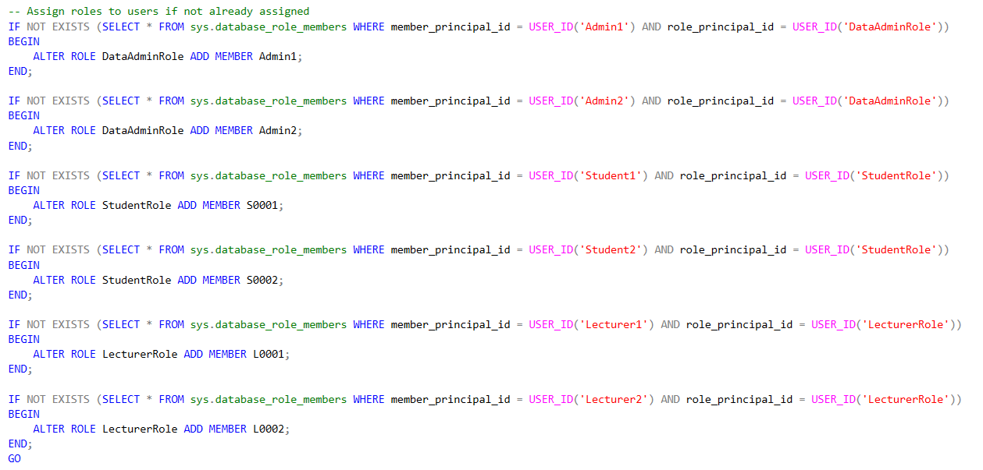

Figure : Code snippet of assigning roles

After creating the roles, logins and users, roles were assigned respectively had as shown in the code above. This ensures that each user has the correct role-based permissions for their actions in the Academic Information System (AIS) to have a more organized access control as well as improving overall security.

### Views

#### Data Admin Role

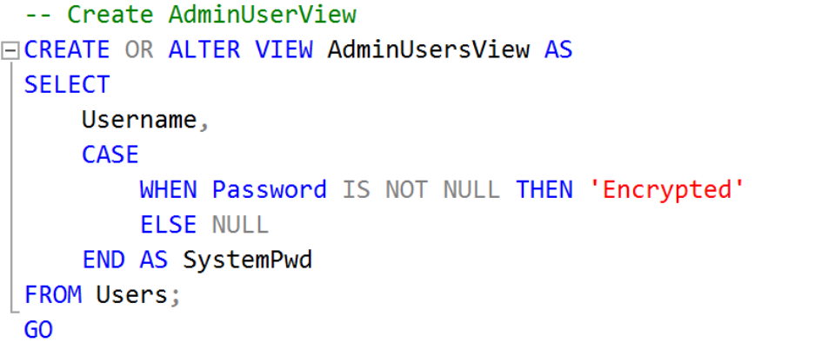

Figure : Code snippet of AdminUsersView

There are a total of 5 views created for the Data Admin Role, the first one called *‘AdminUsersView’* is created to provide a simplified version of user data from the Users table, specifically focusing on the Username and an indication of whether the password is stored securely. This helps in masking sensitive password information from being displayed directly while still confirming that a password exists for the user. When coding this view, it is crucial to ensure that sensitive information is not exposed.

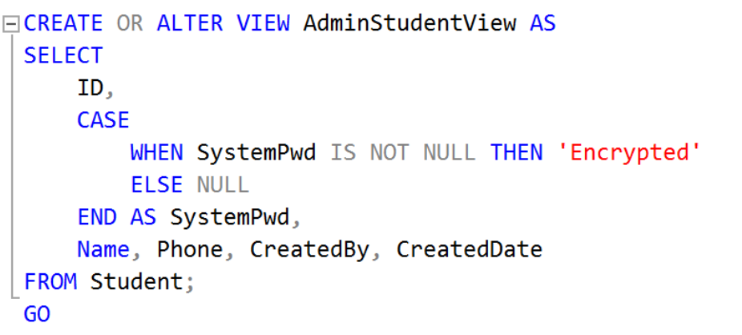

Figure : Code snippet of AdminStudentView

The *‘AdminStudentView’* offers a filtered view of student records from the Student table, showing the *ID, Name, Phone*, *CreatedBy*, and *CreatedDate* fields, along with identifying whether password is stored as Encrypted. This view enables admin to manage student data without exposing actual passwords, which maintains privacy and security.

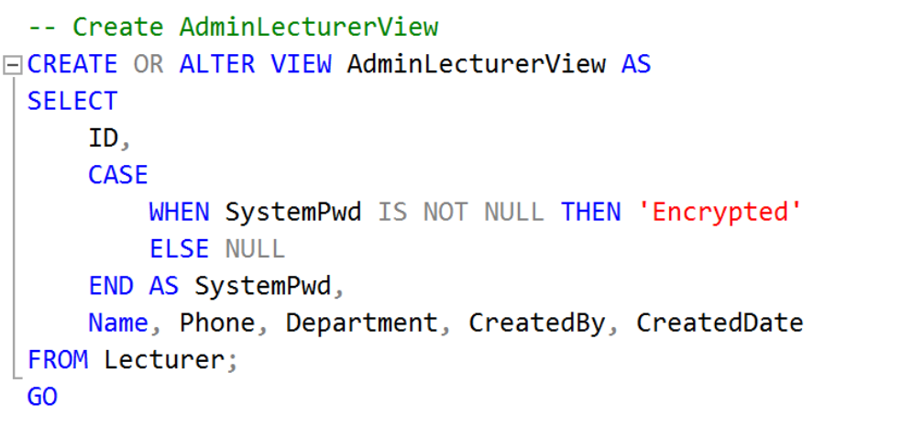

Figure : Code snippet of AdminLecturerView

The *‘AdminLecturerView’* serves a similar purpose as the previous views but focuses on lecturer records from the Lecturer table. It provides details like *ID, Name, Phone, Department,* *CreatedBy*, and *CreatedDate,* alongside a masked *SystemPwd*. This view allows admins to oversee lecturer information without disclosing sensitive password data.

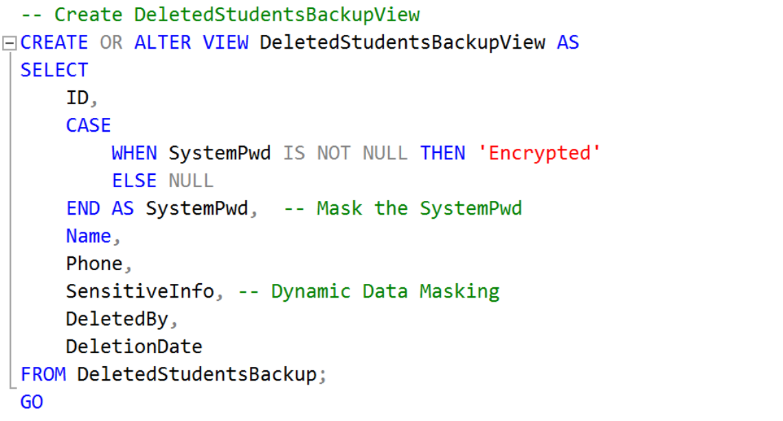

Figure : Code snippet of DeletedStudentsBackup View

The *‘DeletedStudentsBackupView’* is designed to display records of students that have been deleted, providing insight into the *ID, Name, Phone,* and details about who deleted the record *(DeletedBy)* and when *(DeletionDate).* It also masks the *SystemPwd* by showing 'Encrypted' for existing passwords and labels *SensitiveInfo* as being masked by dynamic data masking. This is useful for auditing and recovery processes while maintaining the confidentiality of sensitive data.

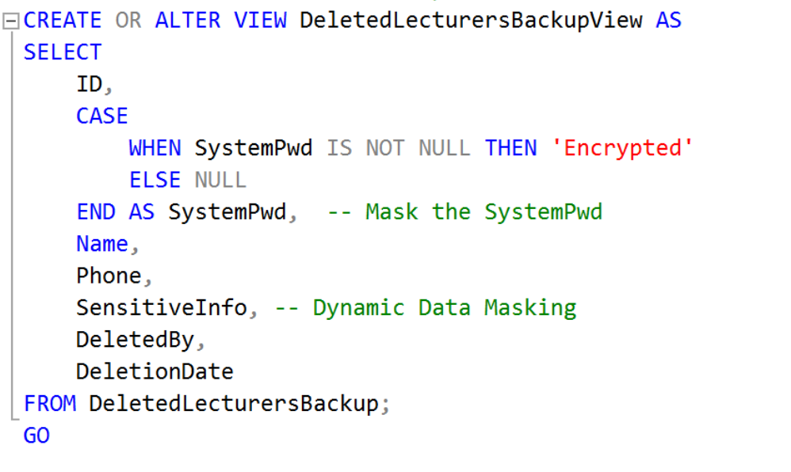

Figure : Code snippet of DeletedLecturerBackupView

The *‘DeletedLecturersBackupView’* functions similarly to the *‘DeletedStudentsBackupView’*, but it is for deleted lecturer records. Similarly, it displays key details like *ID, Name, Phone,* and the deletion information while masking the *SystemPwd* and labelling *SensitiveInfo*. This view allows for tracking of deleted lecturer information without compromising security. The procedure for creating this view also includes checks to prevent errors during updates, ensuring a seamless management process also maintaining the confidentiality of sensitive data.

#### Student Role

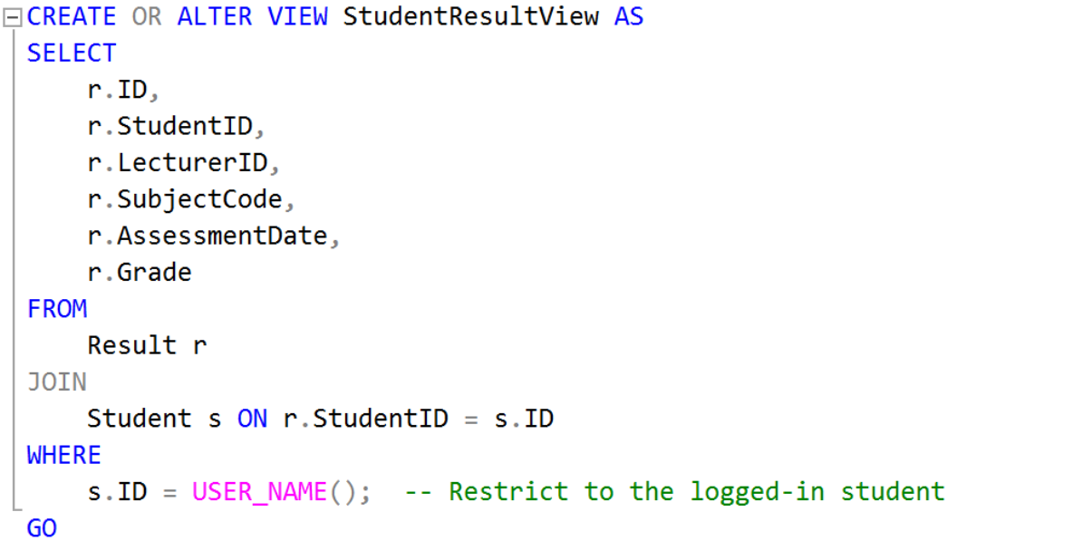

Figure : Code snippet of StudentResultView

The *‘StudentResultView’* is to allow students to view their own academic results while ensuring their data privacy. It retrieves the *ID, StudentID, LecturerID, SubjectCode, AssessmentDate,* and *Grade* from the Result table, but only for the logged-in student, as indicated by the *‘WHERE s.ID = USER_NAME()’* statement. This where condition ensures that each student can only access their results so that all students’ results is secure and confidential.

#### Lecturer Role

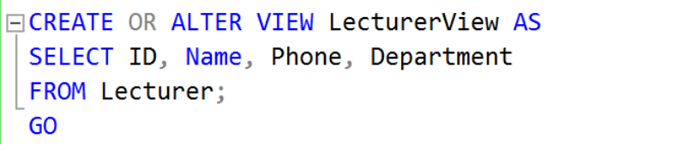

Figure : Code snippet of LecturerView

The *‘LecturerView’* is straightforward, and is a view of lecturer details, such as the ID, Name, Phone, and Department from the Lecturer table. This view is useful for admins or systems that need to manage or present lecturer information without any filtering restrictions, as it allows all relevant lecturer data to be accessed freely. The code just involves a simple *SELECT* statement without additional conditions.

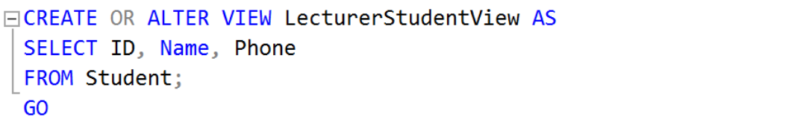

Figure : Code snippet of LecturerStudentView

The *‘LecturerStudentView’* is intended to give lecturers access to essential information about students, like their ID, Name, and Phone numbers. This view facilitates communication and oversight of student details without exposing more sensitive data. Similar to the ‘LecturerView’, it pulls data directly from the Student table without any filters.

### Stored Procedures

#### Student Role

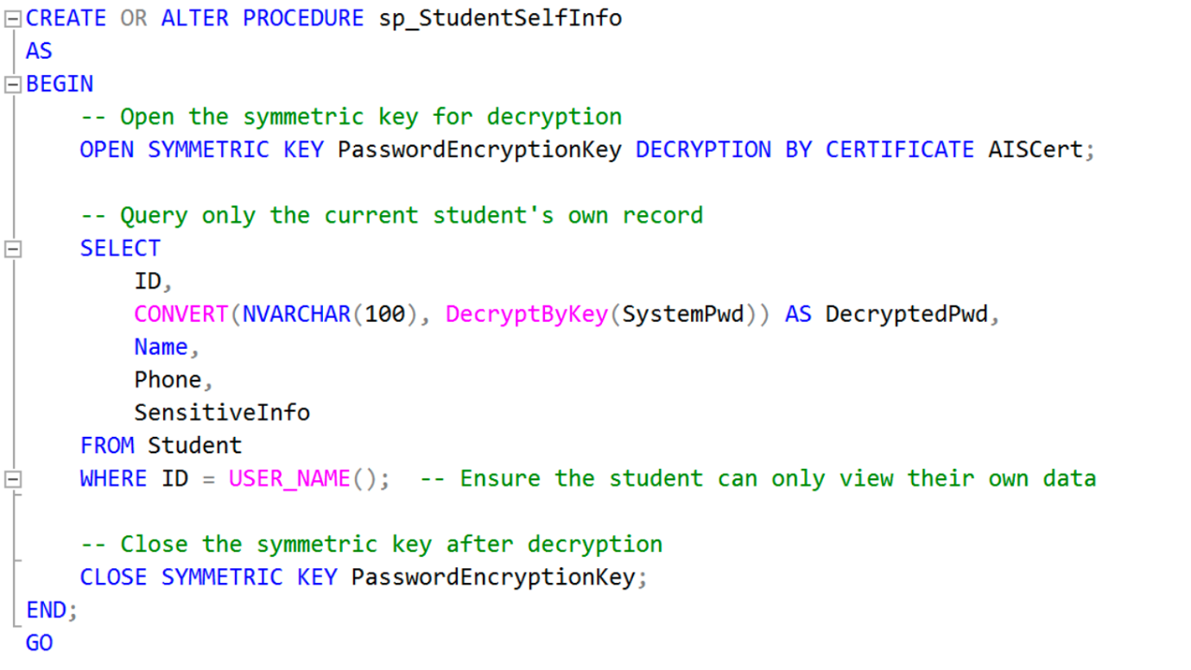

Figure : Code Snippet of sp_StudentSelfInfo

There are two stored procedures for the role of Student, the first stored procedure was created to securely allow students to view their data, including their decrypted password, phone number, and other sensitive details. The procedure opens a symmetric key to decrypt the password, *SystemPwd* for display, ensuring that the student can see their information. The use of the *USER_NAME()* function restricts access so that students can only retrieve their data to prevent unauthorized users viewing other students’ records. This enhances security by allowing direct, secure access to personal information without exposing it to others.

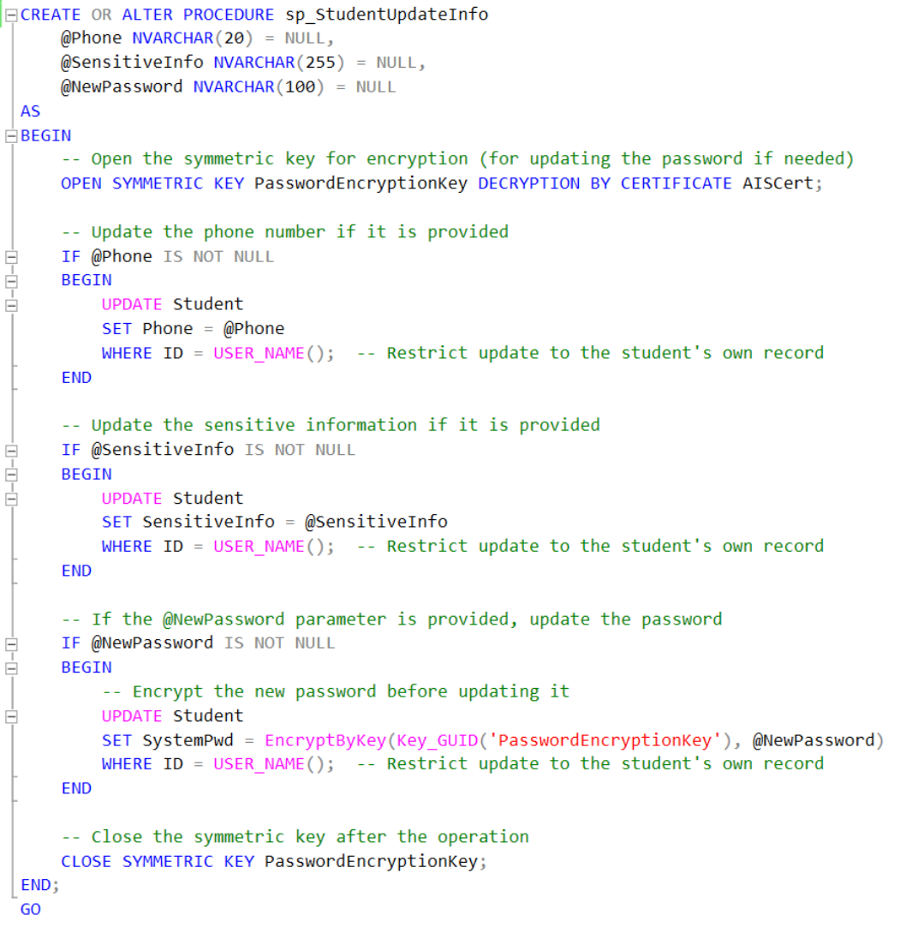

Figure : Code snippet of sp_StudentUpdateInfo

The second store procedure for Student roles enables them to update their details such as phone number, sensitive information, and password. The procedure accepts optional parameters for each field and only updates those that are provided by the user. It uses symmetric encryption to handle password updates securely and restricts the updates to the logged-in student using *USER_NAME().* By allowing students to maintain and update their information, the procedure improves user experience and autonomy while still enforcing security through controlled access and encryption.

#### Lecturer Role

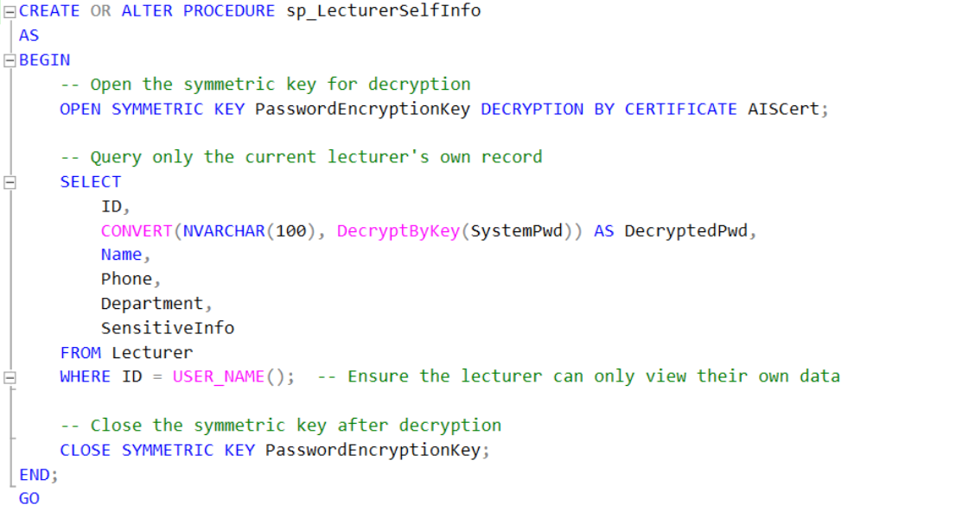

Figure : Code snippet of sp_LecturerSelfInfo

There are also two store procedures for the role of Lecturer, The first is *‘sp_LecturerSelfInfo’,* which is designed for lecturers to safely view their details, including their decrypted password, phone number, department, and other sensitive information. Similar to the student version, it uses a symmetric key to decrypt the password and ensures that lecturers can only access their data using the *USER_NAME()* function.

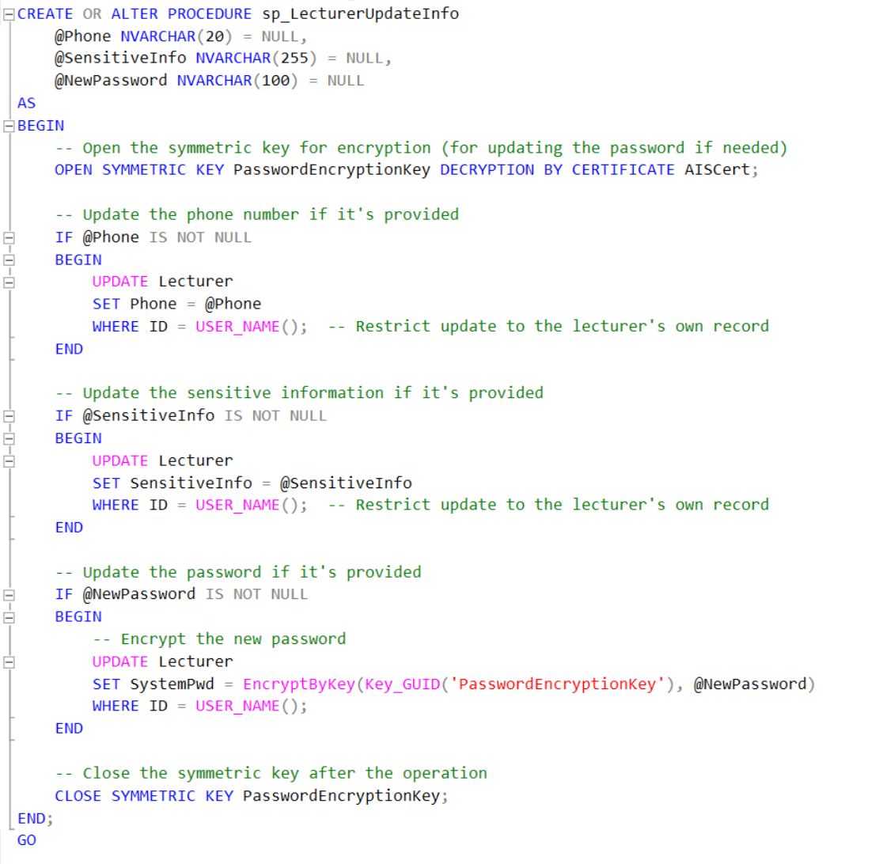

Figure : Code snippet of LecturerUpdateInfo

The second stored procedure allows lecturers to update their phone numbers, sensitive information, and passwords in the database. The procedure opens a symmetric key for password encryption and uses conditional updates based on the provided input parameters. Restricting updates to the logged-in lecturer’s data *(WHERE ID = USER_NAME())*ensures that lecturers can only modify their records to prevent accidentally or purposely changing other lecturers’ data.

### Assign Permissions

#### Data Admin Role

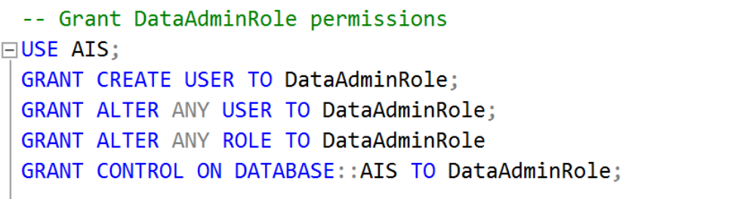

Figure : Code snippet assigning permission to Data Admin Role(1)

In this section, the developer configures the permissions for the *‘DataAdminRole’* to ensure data administrators can effectively manage the system while protecting sensitive information. It started by granting the *‘DataAdminRole’* the ability to manage users and roles within the database. This includes the permissions to create new users *(GRANT CREATE USER)*, modify or delete existing users *(GRANT ALTER ANY USER)*, and alter any role in the system *(GRANT ALTER ANY ROLE)*. Additionally, the role is given control over the entire AIS database *(GRANT CONTROL ON DATABASE::AIS)* so that the admin is at the top of the hierarchy to oversee the database environment.

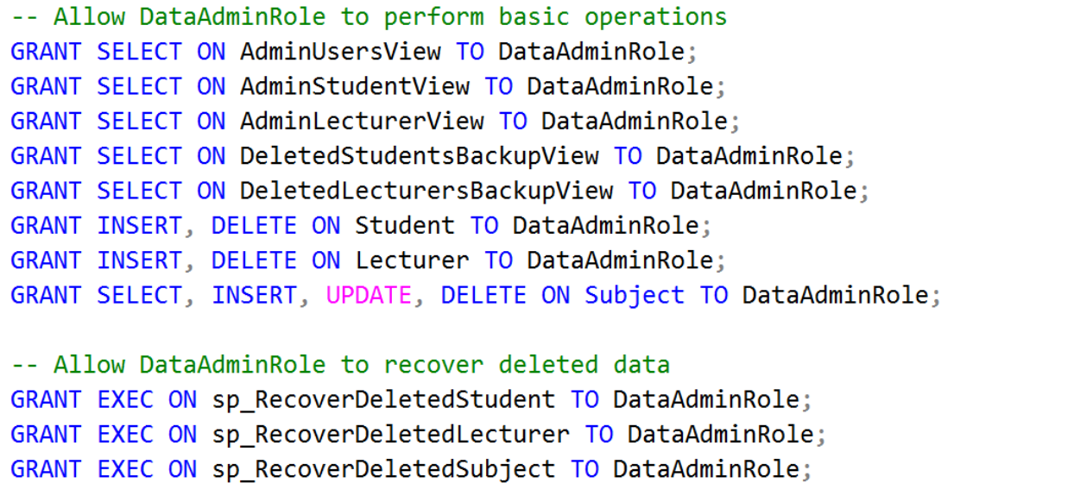

Figure : Code snippet assigning permission to Data Admin Role (2)

Next, the developers ensure that the ‘DataAdminRole’ has all the necessary access to perform basic operations on key data views and tables. For example, SELECT permissions on views that current user, student, and lecturer data *(AdminUsersView, AdminStudentView,* and *AdminLecturerView)*, as well as views related to deleted records *(DeletedStudentsBackupView, DeletedLecturersBackupView)*. For record management, the role is granted INSERT and DELETE permissions on the Student and Lecturer tables to let the admin manage these core entities. Furthermore, full CRUD permissions (SELECT, INSERT, UPDATE, DELETE) are provided on the Subject table so Data Admins can manage academic subjects.

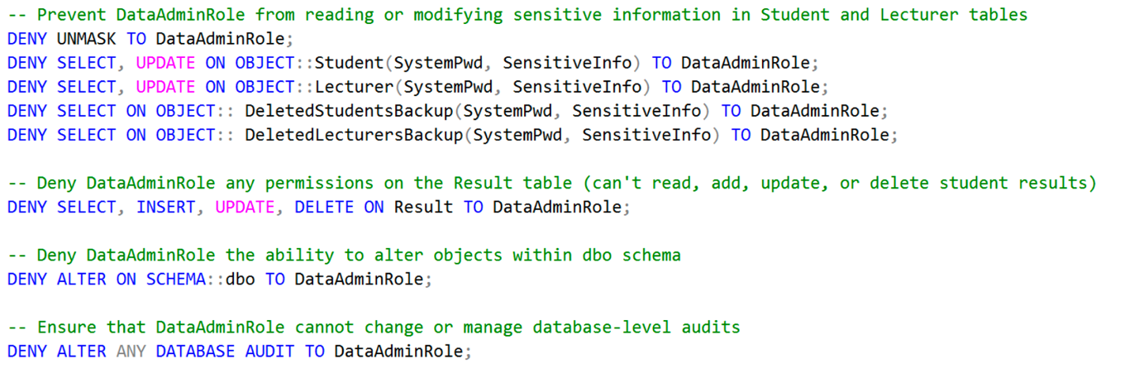

Figure : Code snippet assigning permission to Data Admin Role (3)

While Data Admins are responsible for managing records, strict data protection by limiting access to sensitive information was also enforced. The *DENY UNMASK* statement prevents the Data Admin from viewing sensitive, unmasked information in the deleted record of the Student and Lecturer tables, ensuring that sensitive personal details like encrypted passwords and sensitive fields remain hidden. The *DENY* statements ensure that the *‘DataAdminRole’* cannot view or modify encrypted passwords or sensitive personal information within the Student and Lecturer tables, and the same for backup views like (*DeletedStudentsBackup, DeletedLecturersBackup),* because even deleted records need to preserve their data privacy. In addition to these controls, the role is explicitly denied any access to the Result table too because Data Admins have no right or logically not able to modify or view student assessment data because it should be handled exclusively by lecturers.

Finally, additional security measures are put in place to prevent the *‘DataAdminRole’* from changing the database schema or managing audit logs. This is done by denying permission to alter objects within the dbo schema *(DENY ALTER ON SCHEMA::dbo)* and denying the ability to modify or control database-level audits *(DENY ALTER ANY DATABASE AUDIT).* These restrictions protect the structural integrity of the database and ensure that auditing remains intact.

#### Student Role

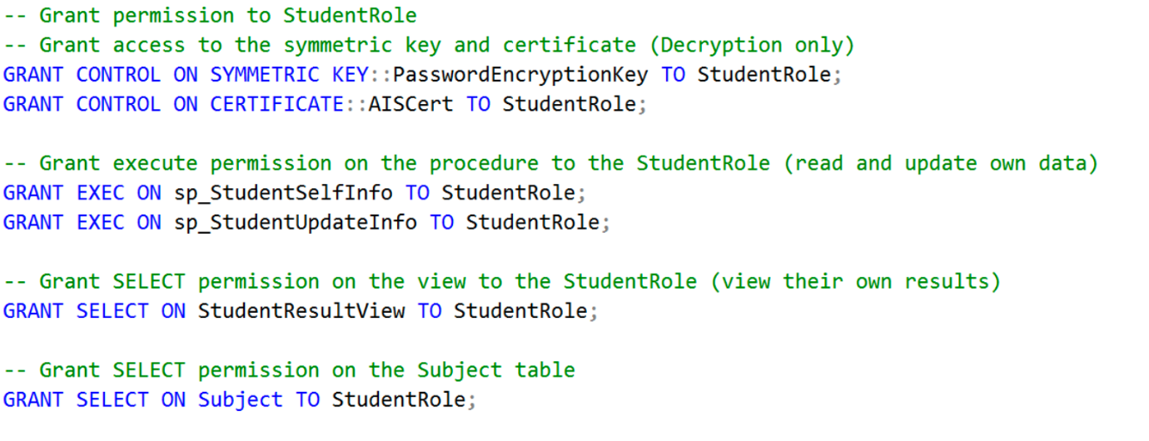

Figure : Code snippet assigning permission to Student Role (1)

The *‘StudentRole’* is configured with a focus on allowing students to securely access and update their information only and restricting access out of their scope. It begins by granting ‘StudentRole’ access to the symmetric key *(PasswordEncryptionKey)* and certificate *(AISCert)* for decryption only. This access enables students to view their encrypted password and update it when necessary without granting the ability to perform encryption themselves to maintain the security of the database. To further support student self-management, the *‘StudentRole’* is also granted *EXECUTE* permissions on stored procedures such as *sp_StudentSelfInfo* and *sp_StudentUpdateInfo*, which allow students to view and update their details. In terms of data access, *‘StudentRole’* is granted *SELECT* permission on *the StudentResultView*, which filters results to display only the own academic data. Students also granted view to subjects in the system on the Subject table. These permissions let students retrieve their relevant academic information while maintaining strict rules on the data they can view.

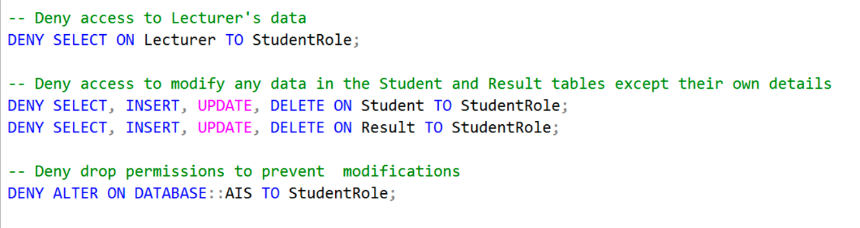

Figure : Code snippet assigning permission to Student Role (2)

To protect the database, students are explicitly denied access to lecturer data, preventing them from viewing or modifying lecturer records *(DENY SELECT ON Lecturer).* Furthermore, students are denied the ability to modify any other student’s data or assessment results. This separation prevents unauthorised access or alterations. Lastly, *DENY ALTER ON DATABASE::AIS* is applied to prevent students from making structural changes to the database. Overall, the permission management for *‘StudentRole’* is designed to balance self-service functionality with robust security controls.

#### Lecturer Role

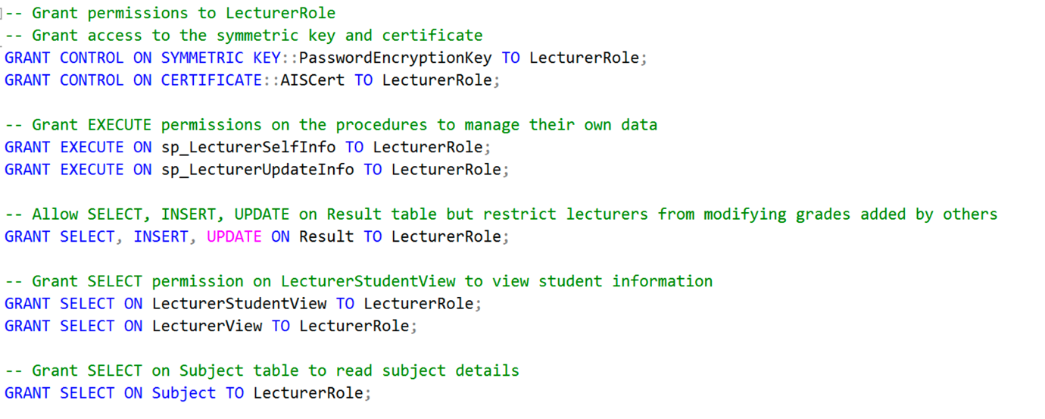

Figure : Code snippet assigning permission to Lecturer Role (1)

The *‘LecturerRole’* is designed to give lecturers the necessary access to manage student results and view relevant academic information. The first step is granting the role control over the symmetric key and cert, which enables lecturers to securely decrypt their passwords for viewing or updating. Lecturers are then granted *EXECUTE* permissions on two key stored procedures, *sp_LecturerSelfInfo* and *sp_LecturerUpdateInfo*, which allow them to view and update their details. This ensures lecturers can maintain their account information securely while ensuring they don’t alter any other lecturer’s data.

A core responsibility of lecturers is managing student results, so the developers grant them *SELECT, INSERT*, and *UPDATE* permissions on the Result table. However, to maintain data integrity, lecturers are restricted from modifying grades that were added by other lecturers. In addition, lecturers are granted *SELECT* permissions on two views, *LecturerStudentView* and *LecturerView*, allowing them to access basic information about students and other lecturers. They also have permission to view academic subjects through the Subject table, helping them to manage course-related tasks.

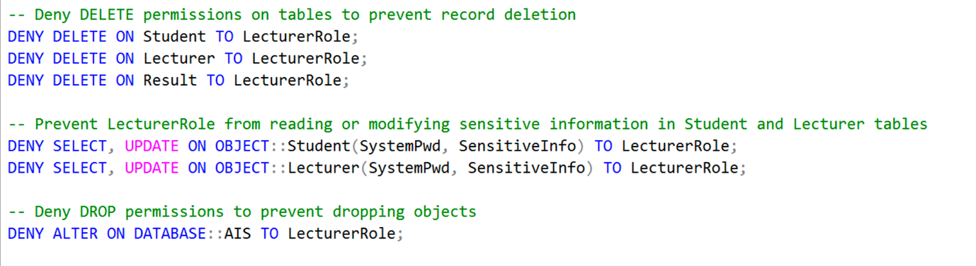

Figure : Code snippet assigning permission to Lecturer Role (2)

Lecturers are denied DELETE permissions to delete records on key tables *(Student, Lecturer, and Result)*. Furthermore, access to sensitive fields like *SystemPwd* and *SensitiveInfo* in both the Student and Lecturer tables is denied, and lecturers cannot view or alter confidential data. Finally, *DENY ALTER ON DATABASE::AIS* prevents lecturers from making structural changes to the database to protect the overall system architecture.

### View Permissions for All Roles

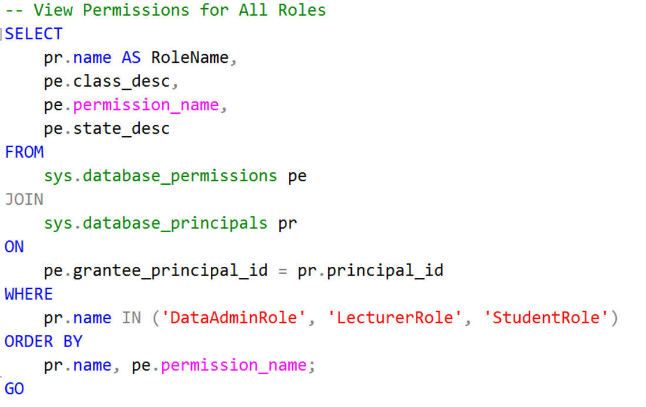

Figure : Code snippet of viewing permission for all roles

This SQL query retrieves the permissions assigned to the roles *‘DataAdminRole’*, *‘LecturerRole’*, and *‘StudentRole’* within the database by joining two system catalogue views: *sys.database_permissions* and *sys.database_principals*. The *sys.database_permissions* view contains details about the various permissions associated with database objects, while the *sys.database_principals* view provides information on the roles and users in the database. By matching the *grantee_principal_id* in the *sys.database_permissions* view with the *principal_id* in the *sys.database_principals* view, the query selects the relevant information about each role's permissions. The output is ordered by the role name and permission name, making it easy to read and analyse.

### Manage Permissions

#### Data Admin Role

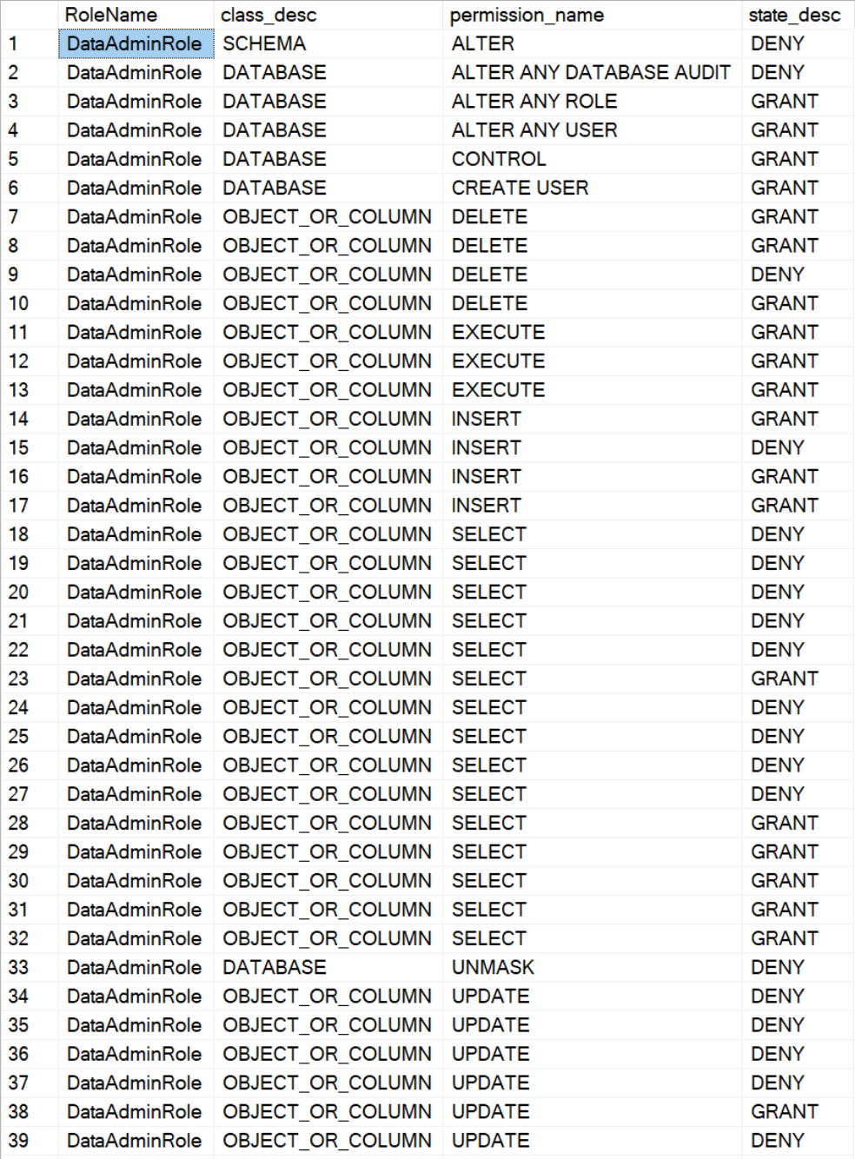

Figure : Output of permissions assigned to Data Admin Role

The output shows the permissions assigned to the *DataAdminRole*, showing detailed control over data access and management tasks. The *DataAdminRole* is granted permission to perform certain operations, such as creating users and modifying specific data, but is explicitly denied access to more sensitive or critical tasks. Permissions, like *ALTER* on the schema level and *ALTER* *ANY DATABASE AUDIT,* are denied to ensure the role cannot make structural changes or tamper with audit logs. Similarly, the role is denied *UNMASK* permission, preventing it from viewing sensitive information in unmasked form. Other operations, such as *SELECT*, *INSERT*, *UPDATE*, and *DELETE*, are selectively granted or denied based on the object, ensuring that while the Data Admin can perform routine tasks, access to critical or confidential data remains restricted. This setup enforces security by limiting the scope of the role’s actions and safeguarding sensitive information.

#### Lecturer Role

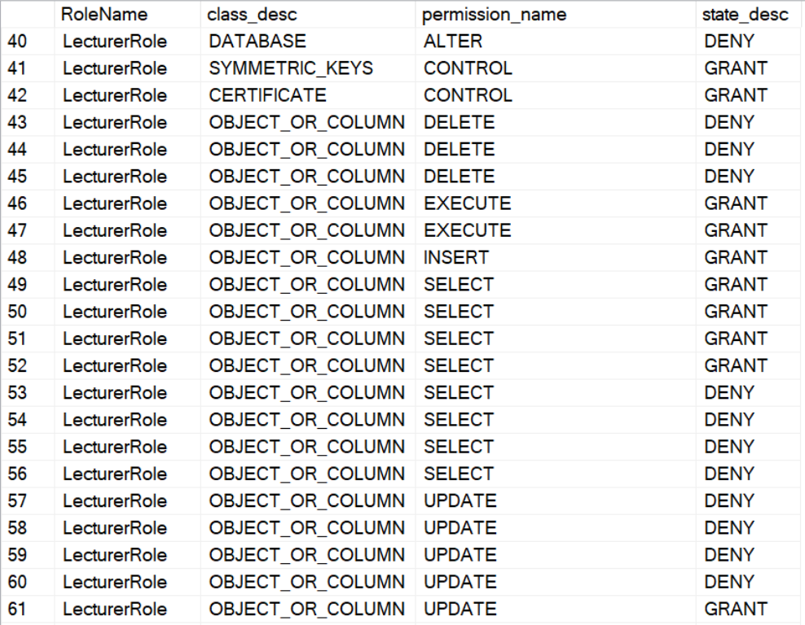

Figure : Output of permission assigned to Lecturer Role

This table shows the permissions assigned to the *LecturerRole*, detailing the role’s access levels to various database objects and operations. The *LecturerRole* is primarily focused on managing data relevant to lecturers, with permissions like *GRANT* for executing, selecting, and inserting records within specific objects or columns, which allows lecturers to perform important tasks such as managing student results. However, the role is restricted from making structural changes to the database schema *(DENY ALTER),* and it is explicitly denied the ability to delete records across various columns, ensuring that lecturers cannot remove sensitive data or alter the system’s integrity. Additionally, the role has *CONTROL* permission over symmetric keys and certificates, enabling secure access to encrypted data. The selective granting of permissions ensures lecturers can perform their duties while maintaining security by limiting their ability to modify or delete critical records.

#### Student Role

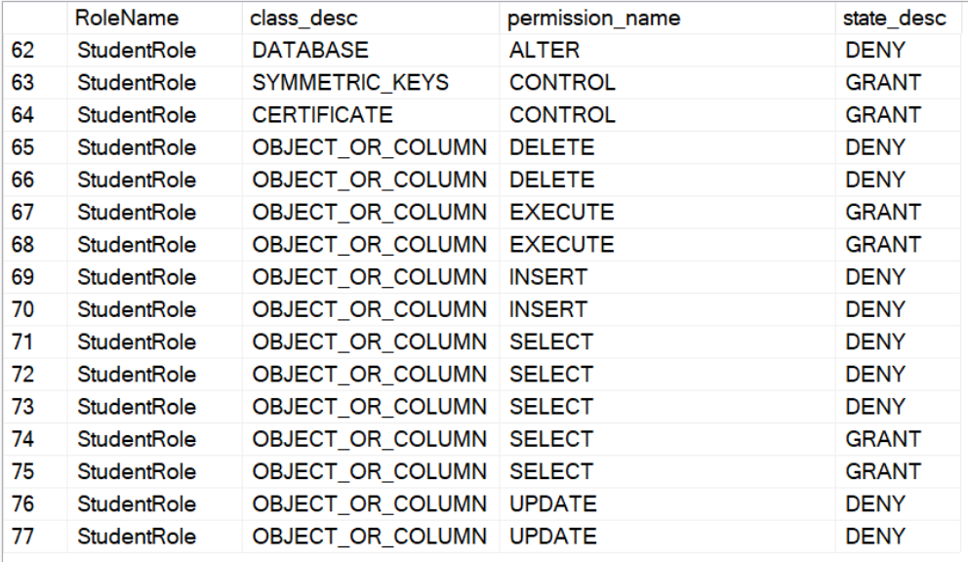

Figure 50: Output of permission assigned to Student Role

This table outlines the permissions assigned to the *StudentRole*. It shows that students have highly restricted access to various database functions, as indicated by the numerous *DENY* statements. For example, the *StudentRole* is denied the ability to delete, insert, or update data in most columns or objects *(DENY DELETE, DENY INSERT, DENY UPDATE)*. However, students have limited *GRANT* permissions for *EXECUTE* functions, likely allowing them to execute specific stored procedures to manage their data. The role has *GRANT* permissions for *CONTROL* on symmetric keys and certificates, which means they can interact with encrypted data specific to their profile. This is critical for handling password encryption or accessing secure data under strict control. Similarly, students have selective *GRANT* permissions to view *(using SELECT)* specific records or columns that pertain to their data while being denied access to other, more sensitive information. The overall setup is to ensure that students can manage their data but are restricted from making changes to the system or viewing unauthorised information.

# Auditing

## Database Audit Matrix

|  |  |  |  |  |
| --- | --- | --- | --- | --- |
| **SQL Object Name** | **SQL Object Type** | **What to Capture** | **Mechanism** | **Audit Log Location** |
| AIS | Database | DDL Changes | Server Audit | var/opt/mssql/audit_logs/ddl_audit/ |
| AIS | Database | Grant, Revoke, Deny permissions | Server Audit | var/opt/mssql/audit_logs/dcl_audit/ |
| Users | SQL Login | Login activities | Server Audit | var/opt/mssql/audit_logs/login_audit |
| Student, Lecturer, Subject, Result | Table | Insert, Update, Delete | Server Audit | var/opt/mssql/audit_logs/dml_audit/ |
| Student, Lecturer, Subject, Result | Table | Insert, Update, Delete | System-versioned Temporal Table | History Tables:  StudentHistory, LecturerHistory, SubjectHistory, ResultHistory |
| Student, Lecturer, Subject | Table | Delete | SQL Triggers | SQL Table:  dbo.DeletedStudentsBackup, dbo.DeletedLecturersBackup, dbo.DeletedSubjectsBackup |

## Consideration for Auditing

### Server Audit

SQL Server Audit is a feature that allows for the monitoring and logging of events at the server and database levels. It tracks various actions, including logins, permission changes, database modifications, etc. Server Audit consists of several components: audit objects that define where the events will be logged, server audit specification, which describes the server-level action to track, and database audit specification, which tracks actions at the database level. These audits can capture actions like Data Definition Language (DDL) changes and Data Manipulation Language (DML) changes and assess control changes (Microsoft Learn, 2024).

The considerations in implementing Server Audit include the level of detail required to track critical actions without impacting performance and the secure storage of logs to maintain their integrity. In AIS, the Server Audit is crucial for ensuring security, accountability, and transparency. It helps to prevent unauthorised access to sensitive student and lecturer data, such as results and personal information, by logging all critical actions. The audit logs help to identify unauthorised or suspicious activities in the system, including unauthorised access, data modification, or security breaches. It provides a comprehensive overview of the management of academic data, which can enhance data protection and the overall reliability of the AIS.

Furthermore, implementing Server Audit in the AIS offers granular control, allowing the administrators to customise audits based on security requirements. This flexibility ensures that the audit focuses on capturing the most critical activity without overloading the system with unnecessary data (Microsoft Learn, 2024). The SQL Server Audit also supports compliance efforts, improves transparency, and strengthens overall data protection. Server Audit also supports compliance with regulatory standards, enhances data protection, and strengthens the overall reliability of the system by allowing prompt identification of unauthorised or suspicious activities (Data Sunrise, n.d.). The collected logs can also assist in analysing security breaches, making it an essential tool for maintaining the integrity and security of the AIS.

### System-Versioned Temporal Tables

System-versioned temporal tables are a feature in SQL Server that allows the storage and management of historical data changes within a table. These tables automatically keep a history of changes made to the data, allowing easy analysis at specific points in time. When data in the table is modified, the old version of the data is stored in a separate history table, while the current table maintains the most recent data. The SQL Server automatically manages the validity period of each record. It uses hidden columns to track when a record becomes valid and when a new version replaces it. This feature allows us to perform point-in-time queries, see previous versions of the data and recover historical records automatically (Microsoft Learn, 2024).

In AIS, system-version temporal tables provide significant benefits by tracking changes to important information, such as personal information and grades. The automatic management of data changes ensures transparency and accountability, allowing the administrators to audit data modifications and report precious records when necessary. The system efficiently handles current and historical data, maintaining high performance for active queries while keeping a comprehensive history for compliance and recovery needs. By implementing system-versioned temporal tables, the AIS enhances its ability to maintain data integrity, ensure compliance, and protect sensitive information while ensuring seamless performance.

### SQL Triggers

SQL triggers are stored procedures that automatically run when specific events like DDL operations, including *CREATE, ALTER, and DROP*, and DML operations, including *INSERT*, *UPDATE*, or *DELETE,* in a database. These triggers are useful for auditing as they capture real-time changes, including who made the changes and when they happened (Microsoft Learn, 2024). It provides an essential mechanism for maintaining data integrity and ensuring compliance with security policies by automatically logging critical actions. However, triggers can introduce processing overhead, especially in high-transaction systems, so they must be used thoughtfully to avoid performance issues (Moore, 2019).

In AIS, SQL triggers are useful for tracking any accidental or intentional deletion of records. These triggers automatically log details about who deleted the data and when the deletion occurred, ensuring that all data removal actions are recorded for auditing. This is essential when maintaining historical data and where accidental deletions could lead to significant data loss. By using triggers to track deletion, the system provides real-time monitoring of data removal operations, ensuring that even if data is removed intentionally or unintentionally, a log of events is kept. This approach provides a layer of security and accountability, allowing administrators to recover deleted data and investigate potential misuse of the system. Although it may introduce performance overhead, the benefit of auditability and data recovery makes them a valuable tool in protecting and managing sensitive academic records within AIS.

## Implementation

### Server Audit

#### Audit Object

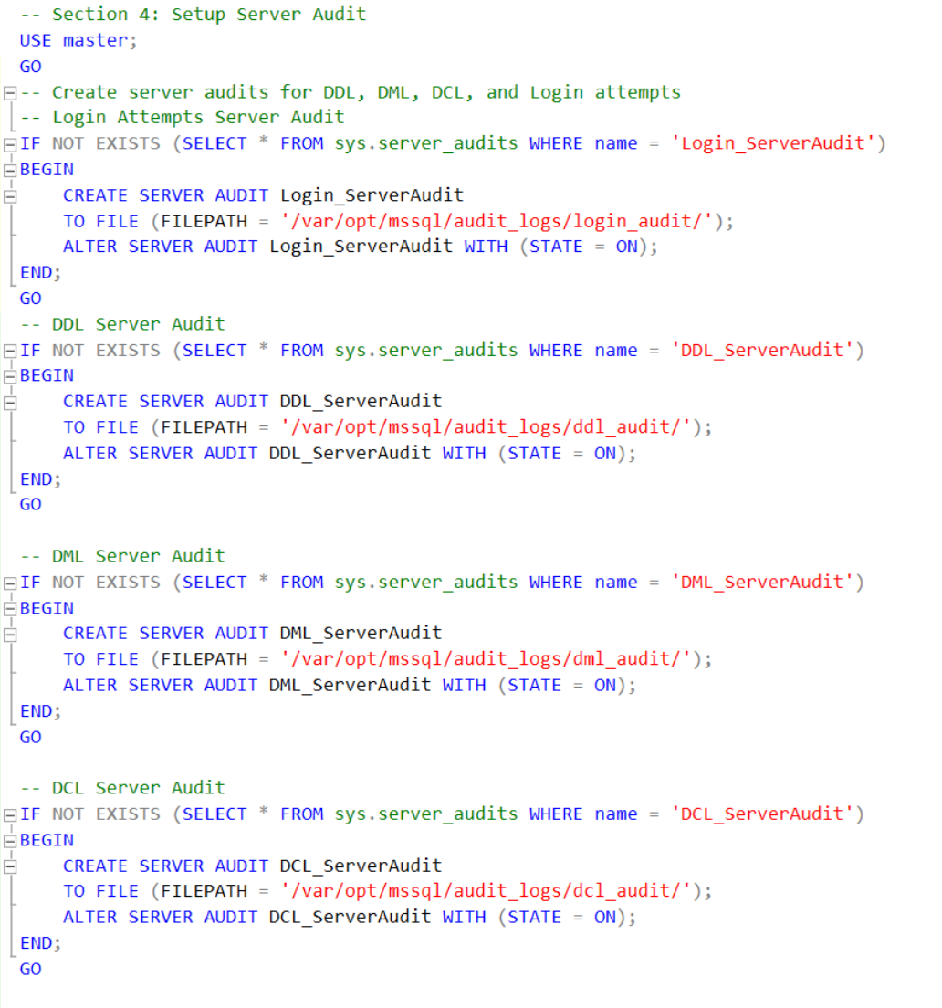

Figure : Code snippet of Audit Objects

The code snippet creates and allows server audits to monitor activities such as Data Definition Language (DDL), Data Manipulation Language (DML), Data Control Language (DCL), and login attempts in SQL Server. Each action, including data modification, data updates or deletions, permission changes, and login attempts, is audited separately. The audit log for these events is saved in specific file paths. Each audit is set to an active state using ALTER SERVER AUDIT, which allows continuous monitoring of these activities.

#### Server Audit Specification

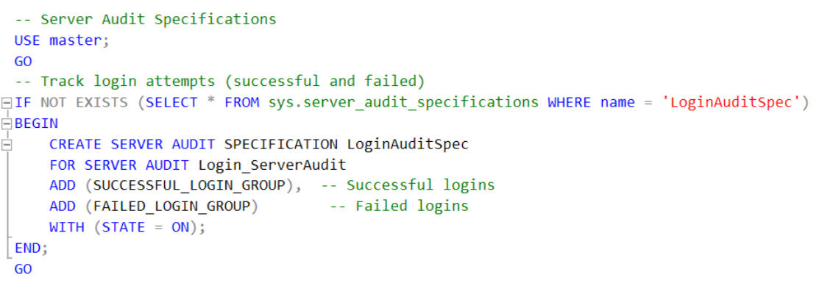

Figure : Code snippet of Server Audit Specification

The code snippet defines the audit specification for server activities to track login attempts for both successful and failed login. By tracking successful logins, administrators can see which users accessed the system. Meanwhile, logging failed logins provides critical insight into potential security threats, such as unauthorised access attempts. This mechanism enhances the security of the AIS by providing detailed visibility into login events, helping to ensure system integrity and prevent unauthorised access.

#### Database Audit Specification

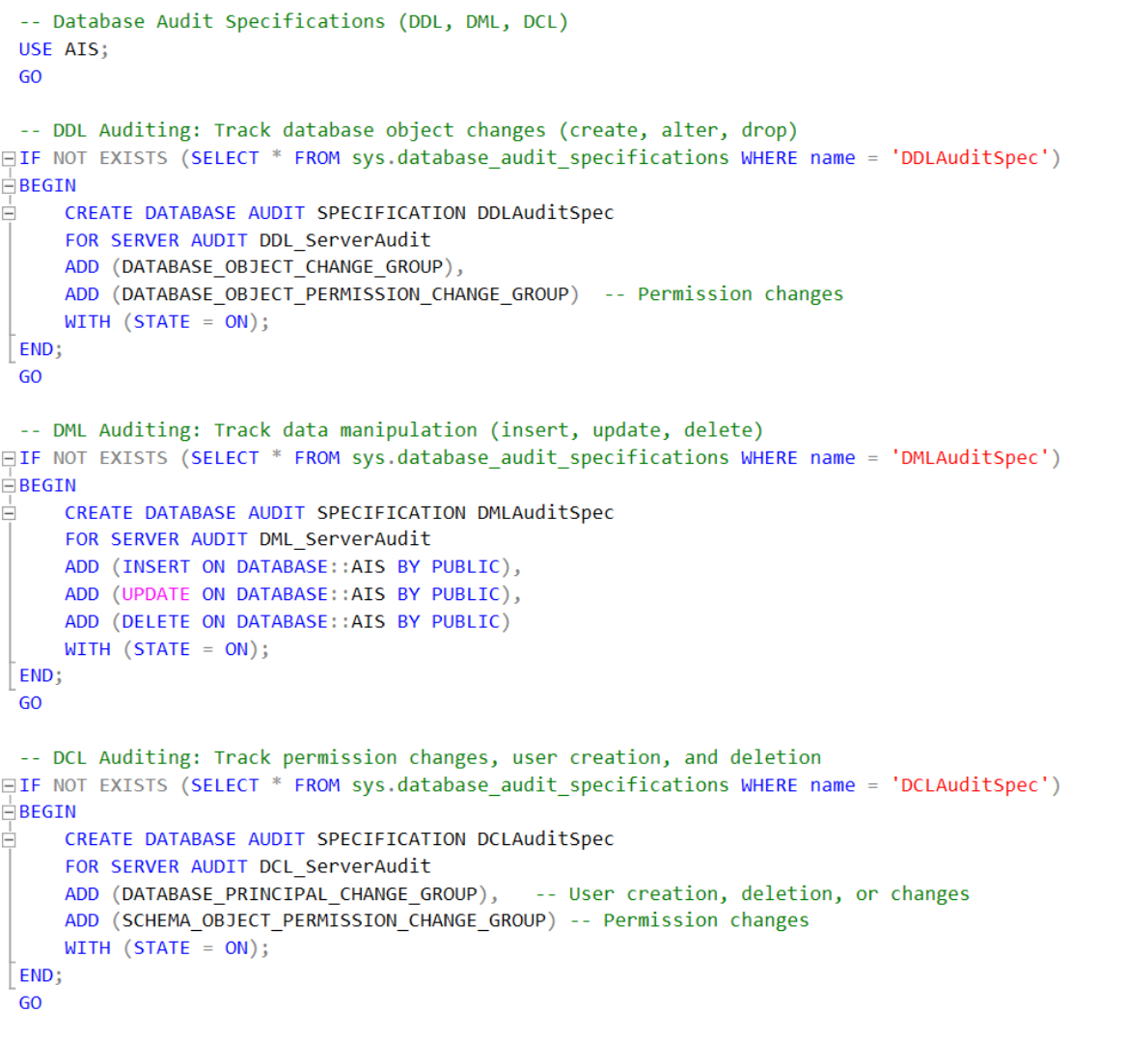

Figure : Code snippet of Database Audit Specification

The code snippet defines audit specifications for database activities such as DDL, DML, and DCL. The DDL auditing records changes to the database structure, including creating, altering, and dropping objects, as well as capturing permission modifications. DML auditing monitors data manipulation operations like inserts, updates, and deletes, ensuring any changes to data are logged. DCL auditing focuses on tracking user-related actions, including user creation, deletion, and permission changes, providing a comprehensive view of access control activities within the AIS.

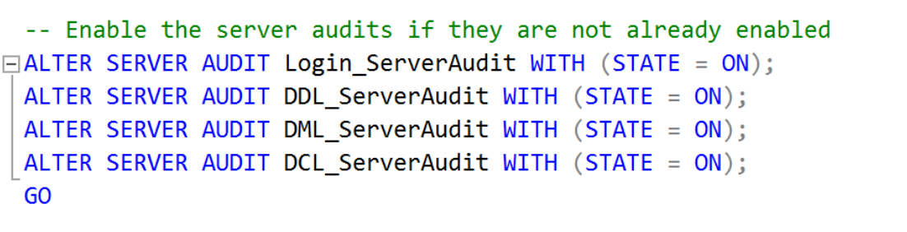

Figure : Code snippet of enabling server audits

The code snippet ensures that the server audits for each activity are enabled if they are not already active. By using the *ALTER SERVER AUDIT* statement with the *WITH (STATE = ON)* statement, it activates login for login attempts, database structure changes, data manipulation activities and user-related actions. This allows a comprehensive tractive of important database activities, improving security, accountability and compliance.

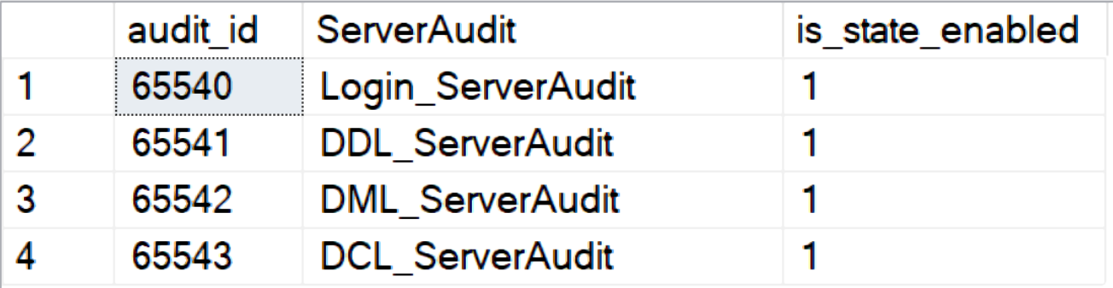

Figure : Output of checking server audit

The output shows the server audits and are currently enabled. Each audit is actively monitoring data activities like login attempts, object changes, data manipulation, and permission changes.

#### Login Server Audit

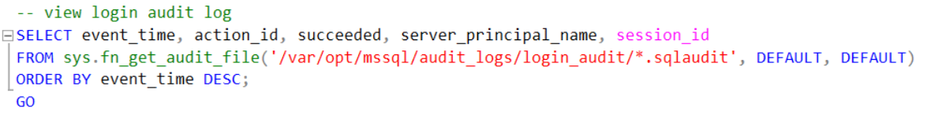

Figure : Code snippet of login server audits

The code snippet retrieves the login audit records, showing details such as *event_time*, *action_id*, when the login succeeded, the *server_principal_name*, and *session_id*. The code reads from audit files from which it was saved, filters them, and sorts the results by even time in descending order to show the most recent login attempt first.

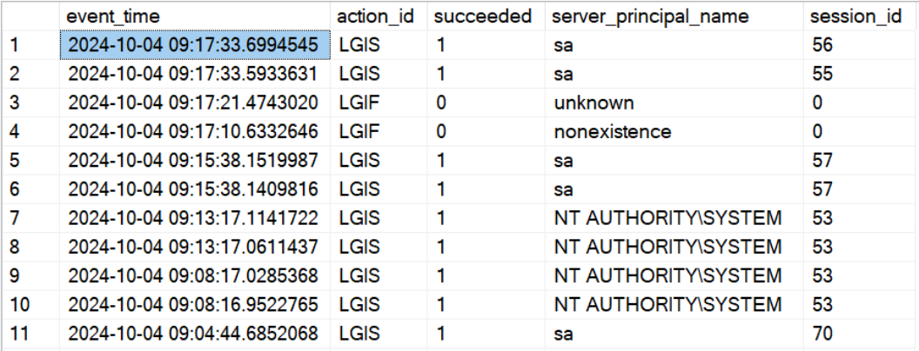

Figure : Output of login server audit

The output shows the login audit log, detailing the *event_time* of login attempts, the *action_id*, LGIS for successful, LGIF for failed logins, whether the attempt succeeded, 1 for success, 0 for failure, the *server_principal_name* and the *session_id*.

#### DDL Server Audit

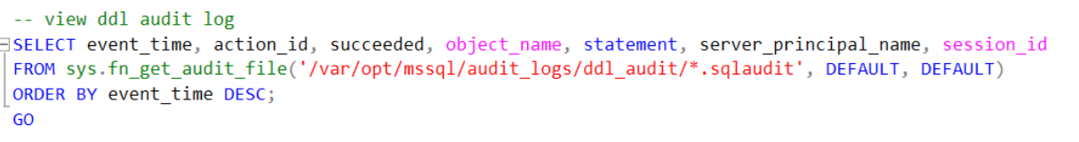

Figure : Code snippet of DDL Server Audit

The code snippet retrieves the DDL audit records, showing details such as *event_time*, *action_*id, the *object_name* involved, the *statement* executed, whether the action *succeeded*, the *server_principal_name*, and the *session_id*. The code reads from audit files from which it was saved, filters them, and sorts the results by even time in descending order to show the most recent database structure changes first.

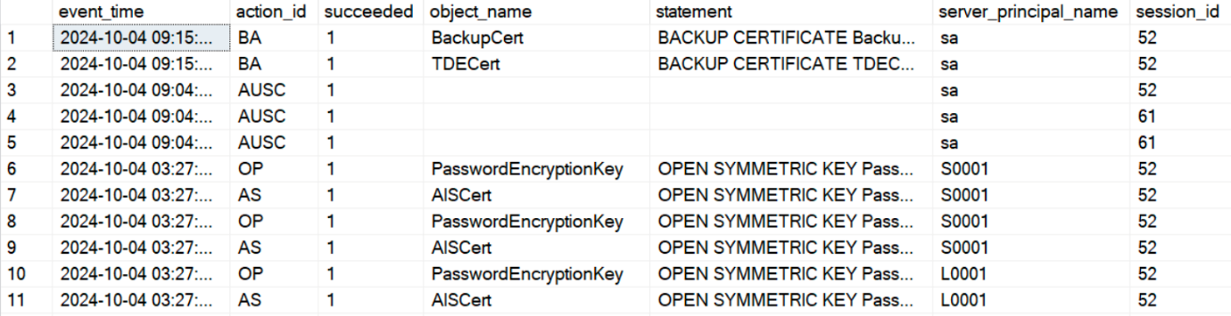

Figure : Output of DDL Server Audit

This output shows the DDL audit log, detailing the *event_time* of actions performed on the database, the *action_id*, which indicates the type of action performed, whether the action succeeded, the *object_name* that was affected by the action, the statement detailing the SQL operation executed, the *server_principal_name*, which shows the user who performed the action, and the *session_id*, which refers to the session in which the action took place. This allows tracking of key operations, such as changing database structure, which are critical for security auditing and data integrity.

#### DML Server Audit

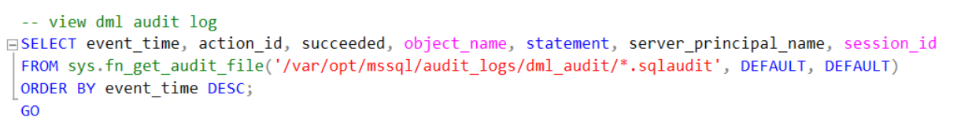

Figure : Code snippet of DML Server Audit

The code snippet retrieves the DML audit records, showing details such as *event_time*, *action_*id, the *object_name* involved, the *statement* executed, whether the action *succeeded*, the *server_principal_name*, and the *session_id*. The code reads from audit files from which it was saved, filters them, and sorts the results by even time in descending order to show the most recent data manipulation actions first.

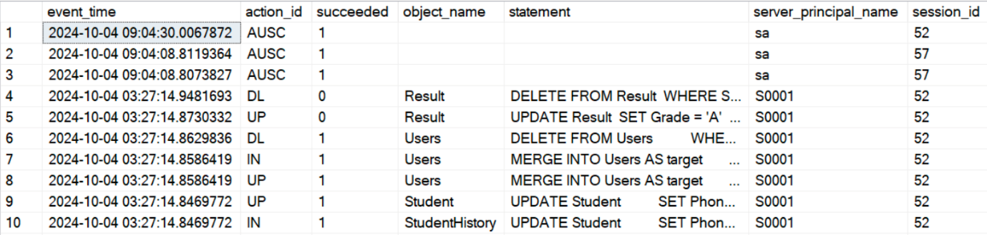

Figure : Output of DML Server Audit

This output shows the DML audit log, detailing the *event_time* of actions performed on the database, the *action_id*, which indicates the type of action performed, whether the action succeeded, the *object_name* that was affected by the action, the *statement* detailing the SQL operation executed, the *server_principal_name*, which shows the user who performed the action, and the *session_id*, which refers to the session in which the action took place. This output helps track data changes like inserts, updates, and deletions, enhancing accountability and security.

#### DCL Server Audit

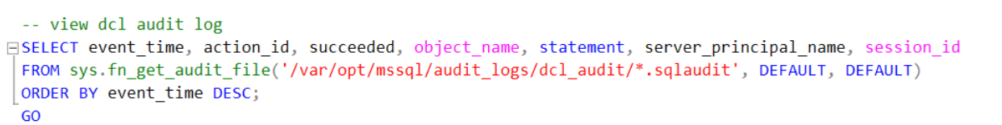

Figure : Code snippet of DCL Server Audit

The code snippet retrieves the DCL audit records, showing details such as *event_time*, *action_*id, the *object_name* involved, the *statement* executed, whether the action *succeeded*, the *server_principal_name*, and the *session_id*. The code reads from audit files from which it was saved, filters them, and sorts the results by even time in descending order to show the most recent DCL activities first.

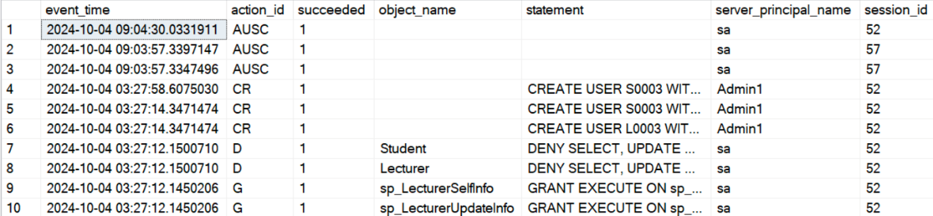

Figure : Output of DCL Server Audit

This output shows the DCL audit log, detailing the *event_time* of actions performed on the database, the *action_id*, which indicates the type of action performed, including create user, deny and grant, whether the action succeeded, the *object_name* that was affected by the action, the *statement* detailing the SQL operation executed, the *server_principal_name*, which shows the user who performed the action, and the *session_id*, which refers to the session in which the action took place. This provides a comprehensive log of permission-related actions, including the creation of users, the granting or denial of permissions, and the execution of stored procedures.

### System-Versioned Temporal Tables

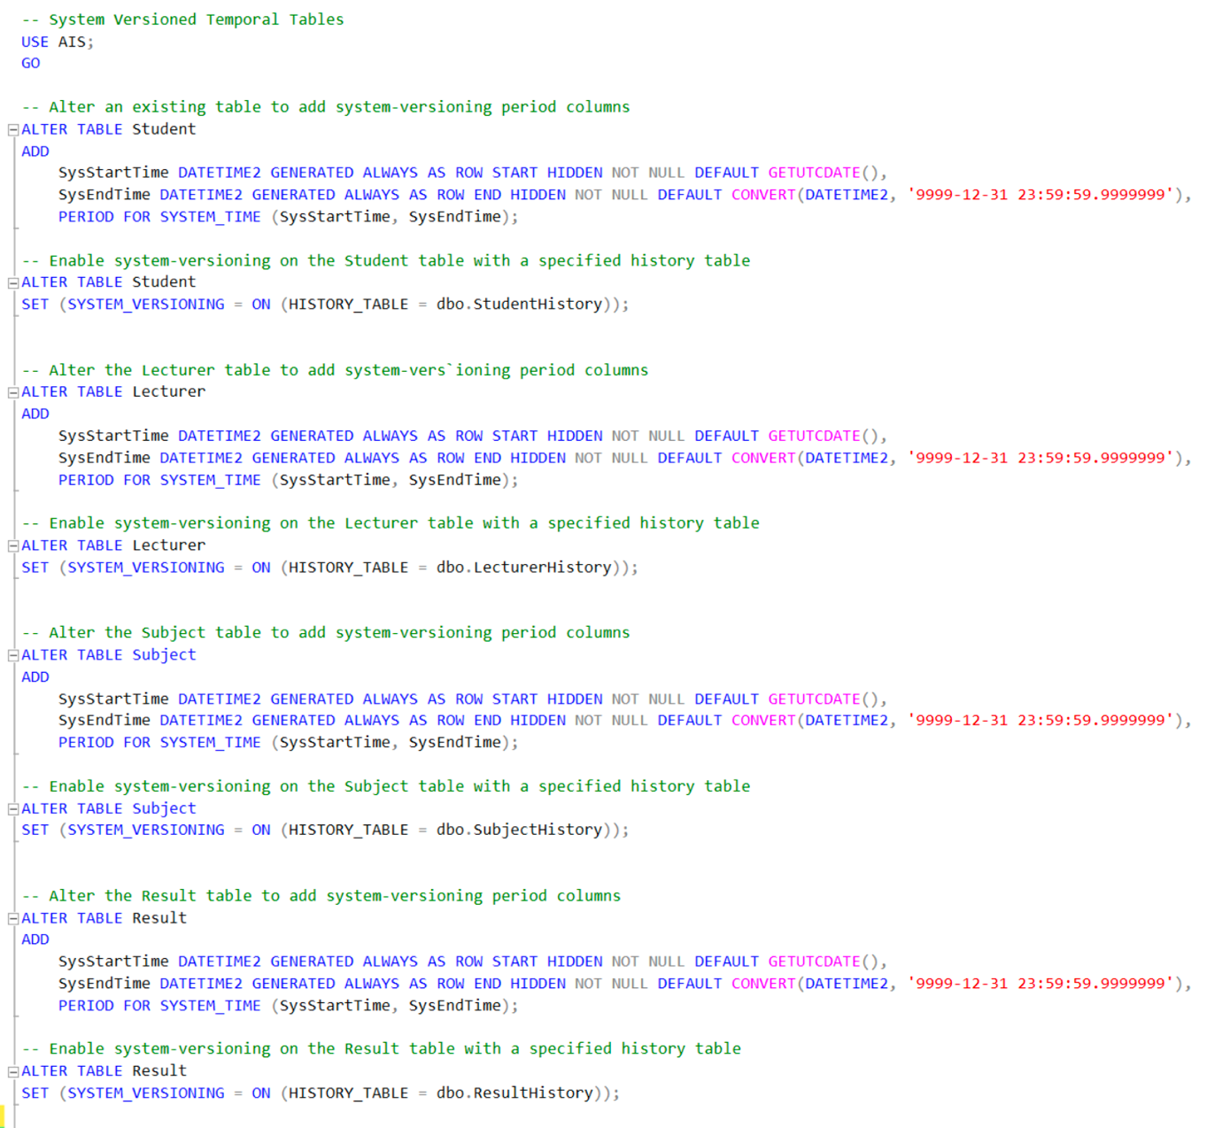

Figure : Code snippet of System-versioned Temporary Tables

The code snippet enables System-Versioned Temporal Tables for the tables in the AIS database: Student, Lecturer, Subject and Result. System-versioning allows the database to track changes over time by tracking when data was inserted, updated, or deleted. To achieve this, the code alters each existing table by adding two columns: *SysStartTime* and *SysEndTime*. These columns automatically store the start and end time of the validity of the row, indicating when it was added and when it was updated or deleted.

After adding these columns to the tables, system-versioning is enabled for each table, linking the table to its respective history table, including *StudentHistory*, *LecturerHistory*, *SubjectHistory* and *ResultHistory*. The history table stores previous versions of each row, allowing it to retrieve data as if it existed at any time. This ensures that any changes to the original table are recorded and kept.

### SQL Triggers

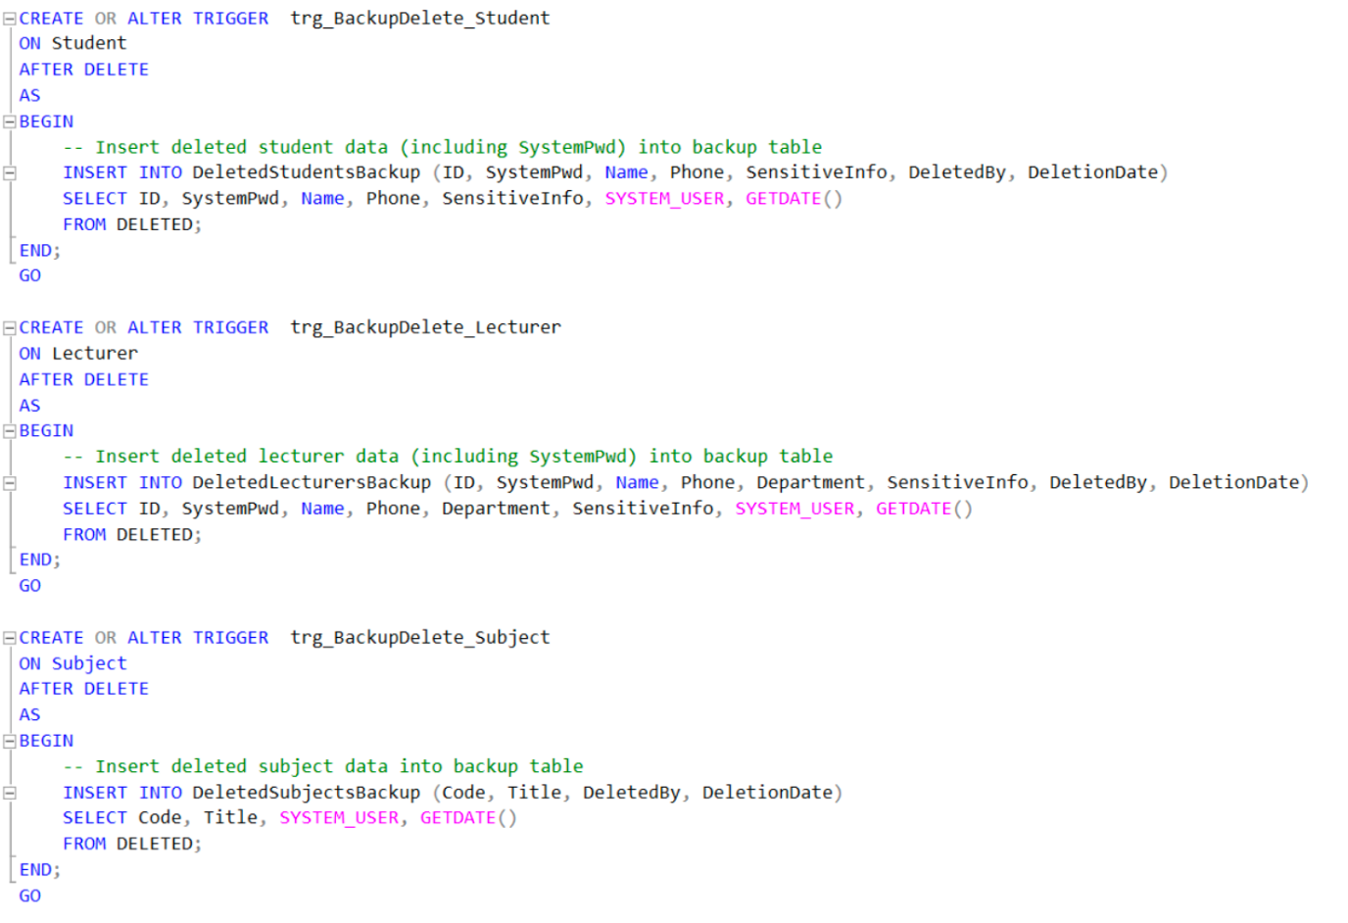

Figure : Code snippet of SQL Triggers

The code snippet defines auditing triggers that are executed after a record is deleted from the Student, Lecturer and Subject tables. These triggers capture important details of the deleted records, including ID, encrypted passwords, name, phone number, and other sensitive information, along with who performed the deletion and the time of the action. This data is then inserted into corresponding backup tables respectively. The purpose of these triggers is to create an auditing mechanism that makes sure any deletion is recorded and stored for future reference. These triggers contribute to the auditing process by tracking who deleted the data, when it was deleted, and what specific data was deleted. This approach provides a layer of accountability and transparency, ensuring all changes, whether it is accidental or intentional, are documented.



Figure : Output of SQL Trigger (Student)

The output shows an example of the audit log captured by the trigger for a deletion in the *DeletedStudentsBackup* table.

# Summary

In summary, this documentation outlines the comprehensive security enhancements implemented for the Academic Information System (AIS) at AP College to address critical data protection needs. Our team employed Microsoft SQL Server Management Studio to establish a robust security framework, which includes a detailed authorisation matrix tailored for various user roles, ensuring that access to sensitive information is appropriately managed. Additionally, we integrated advanced data protection techniques, such as encryption and data masking, alongside a strategic backup and recovery plan designed to safeguard against data loss. We also implemented a thorough auditing system to monitor database activities and ensure compliance with data security standards. These measures collectively enhance the integrity and confidentiality of the college's academic records, fortifying the AIS against unauthorized access and ensuring compliance with established data security standards.

# References

Data Sunrise. (n.d.). *Database Audit in SQL Server*. Retrieved from Data Sunrise: https://www.datasunrise.com/knowledge-center/database-audit-in-sql-server/

Fellows, R., & Crocetti, P. (5 July, 2024). *Types of backup explained: Full, incremental, differential, etc.* Retrieved from https://www.techtarget.com/searchdatabackup/feature/Full-incremental-or-differential-How-to-choose-the-correct-backup-type: TechTarget

Microsoft Learn. (1 March, 2023). *Differential backups (SQL Server)*. Retrieved from Microsoft Learn: https://learn.microsoft.com/en-us/sql/relational-databases/backup-restore/differential-backups-sql-server?view=sql-server-ver16

Microsoft Learn. (5 December, 2023). *Full database backups (SQL Server)*. Retrieved from Microsoft Learn: https://learn.microsoft.com/en-us/sql/relational-databases/backup-restore/full-database-backups-sql-server?view=sql-server-ver16

Microsoft Learn. (15 May, 2024). *SQL Server Audit (Database Engine)*. Retrieved from Microsoft Learn: https://learn.microsoft.com/en-us/sql/relational-databases/security/auditing/sql-server-audit-database-engine?view=sql-server-ver16

Microsoft Learn. (29 July, 2024). *Temporal tables*. Retrieved from Microsoft Learn: https://learn.microsoft.com/en-us/sql/relational-databases/tables/temporal-tables?view=sql-server-ver16

Microsoft Learn. (30 July , 2024). *The transaction log*. Retrieved from Microsoft Learn: https://learn.microsoft.com/en-us/sql/relational-databases/logs/the-transaction-log-sql-server?view=sql-server-ver16

Microsoft Learn. (17 September, 2024). *Track data changes (SQL Server)*. Retrieved from Microsoft Learn: https://learn.microsoft.com/en-us/sql/relational-databases/track-changes/track-data-changes-sql-server?view=sql-server-ver16

Microsoft Learn. (1 September, 2024). *Transparent data encryption (TDE)*. Retrieved from Microsoft Learn: https://learn.microsoft.com/en-us/sql/relational-databases/security/encryption/transparent-data-encryption?view=sql-server-ver16

Moore, L. (9 April, 2019). *Pros and cons of using SQL Server audit triggers for DBAs* . Retrieved from TechTarget: https://www.techtarget.com/searchdatamanagement/tip/Pros-and-cons-of-using-SQL-Server-audit-triggers-for-DBAs

Shiftan, A. (30 June, 2023). *Column-Level Encryption 101: What is It, implementation & Benefits*. Retrieved from Piiano: https://www.piiano.com/blog/column-level-encryption

Technotc. (29 August, 2024). *What is Data Backup and Recovery? A Comprehensive Guide*. Retrieved from Techno Advantage: https://technoadvantage.com/what-is-data-backup-and-recovery/

Zendata. (27 March, 2024). *Data Masking: What It Is and 8 Ways To Implement It*. Retrieved from Zendata: https://www.zendata.dev/post/data-masking-what-it-is-and-8-ways-to-implement-it

Zhang, E. (5 May, 2023). *What is Role-Based Access Control (RBAC)? Examples, Benefits, and More*. Retrieved from Digital Guardian: https://www.digitalguardian.com/blog/what-role-based-access-control-rbac-examples-benefits-and-more